**COMP3010 CW2**

Contents

Introduction: 2

SOC Roles and Incident Handling Reflection: 2

Installation and Data Preparation: 2

Splunk Installation: 2

BOTSv3 Dataset Preparation: 7

Guided Questions: 12

Question 1: 12

Question 2: 12

Question 3: 13

Question 4: 14

Question 5: 15

Question 6: 15

Question 7: 16

Question 8: 17

Conclusions: 18

References: 18

# Introduction:

In this report, I will be analysing the BOTSv3 dataset within Splunk. The BOTSv3 dataset is a public dataset made up of 2,083,056 events which simulates an incident to allow cyber security professionals to practice event analysis and threat hunting in a simulated environment. By utilising the 3 tiers of SOC – triage, investigation and hunting – users can answer a series of questions to determine how the incident occurred, including information about the user(s) and device(s) involved. This report will focus on 8 of those questions, explaining their relevance to SOC, as well as how to install Splunk and how to prepare the BOTSv3 dataset for analysis.

# SOC Roles and Incident Handling Reflection:

## SOC:

* 3 tiers – Triage, Investigation and Hunting
* BOTSv3 dataset mainly focusses on tier 2 as the events have already been contained and are available to be analysed within Splunk to determine how the incidents occurred
* Tier 1 – Triage: Monitor dashboards and events to determine if an incident has occurred
* Tier 2 – Investigation: Checking logs and confirming that incidents have occurred, as well as containing these incidents to determine how they occurred
* Tier 3 – Hunting: Advanced analysis of the threats to determine the best future prevention methods and how to improve overall security

## Prevention:

* Involves mitigating the risk of an incident rather than directly stopping it
* Making sure a system is as secure as it can be
* Implementation of rules and proper system configuration
* Relates to BOTSv3 as the dataset can determine normal user behaviour which can then be used to identify any outliers which could potentially lead to an attack through use of filters, searches and reporting inside of Splunk

## Detection:

* Involves identifying incidents which could be considered suspicious and may potentially lead to an attack
* Analysis of network traffic, timestamps, user involvement etc.
* Relates to BOTSv3 as the dataset involves using Splunk to analyse multiple events using filters and searches to determine information about the events, including the user, device type, operating system and file names, as well as other information
* Links to SOC Tier 1 – Triage and SOC Tier 2 – Investigation

## Response:

* Involves containing an incident so it cannot cause any more harm and investigating how it happened
* Relates to BOTSv3 as the dataset contains events which need to be confirmed as incidents which contain information relating to how they occurred, such as the user(s) involved and the type of device used
* Splunk cannot contain the incident in any way since BOTSv3 is a premade dataset and cannot block IP addresses or stop the incident in any way
* Links to SOC Tier 2 – Investigation

## Recovery:

* Involves restoring any affected systems after the incident has been resolved, and improving security to prevent the incident occurring again
* Relates to BOTSv3 as the logs from the dataset are provided after the incident had occurred to be reviewed and determine how to prevent future incidents of a similar type

# Installation and Data Preparation:

This section will explain how Splunk was installed within an Ubuntu Linux virtual machine, as well as how the BOTSv3 dataset was loaded. As I performed the installation before taking screenshots for this section, the screenshots display later timestamps compared to those for the guided questions. To effectively demonstrate the installation of Splunk, I reinstalled it on the same virtual machine which ensured the configuration of the machine remained the same throughout this report.

## Splunk Installation:

To begin, I opened Firefox inside an Ubuntu Linux virtual machine and searched for “splunk enterprise download”, clicking on the first link in the search results.

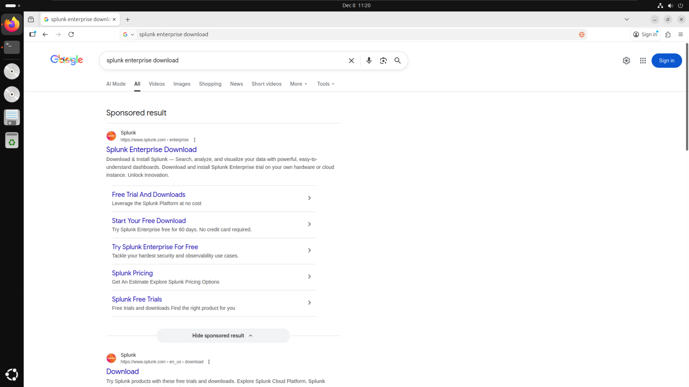

This link took me to the official Splunk website, where I then logged into my account using an account which I had already created.

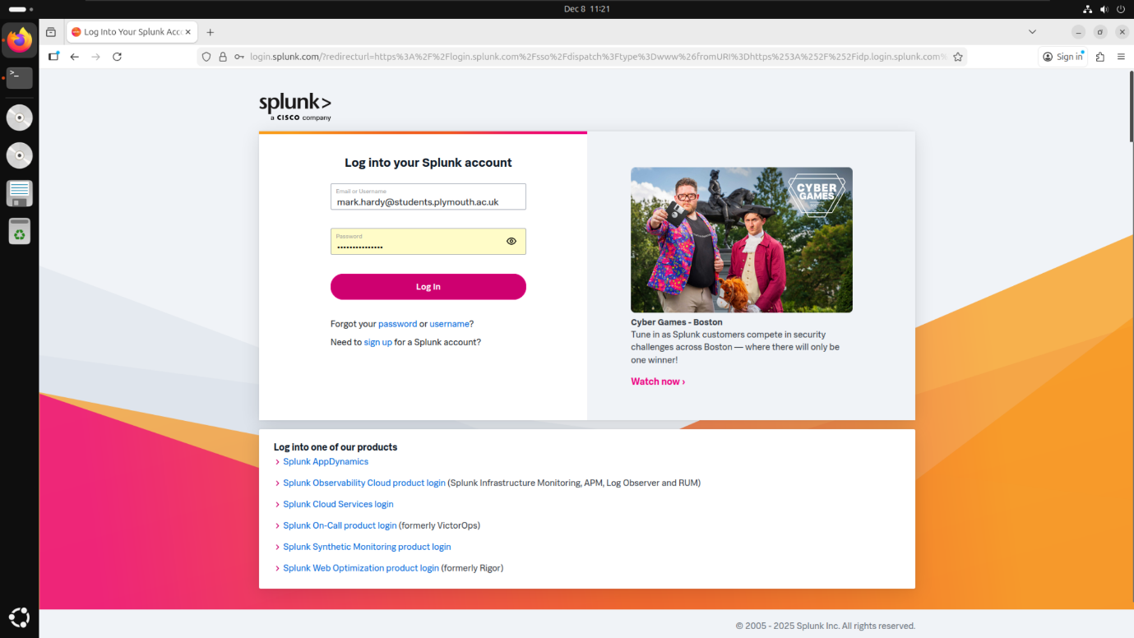

On the “Choose Your Download” page, I selected “Copy wget link” for the .tgz version of Splunk, to ensure that all packages were downloaded alongside the main Splunk software. This meant I did not have to individually download all relevant packages to complete this coursework.

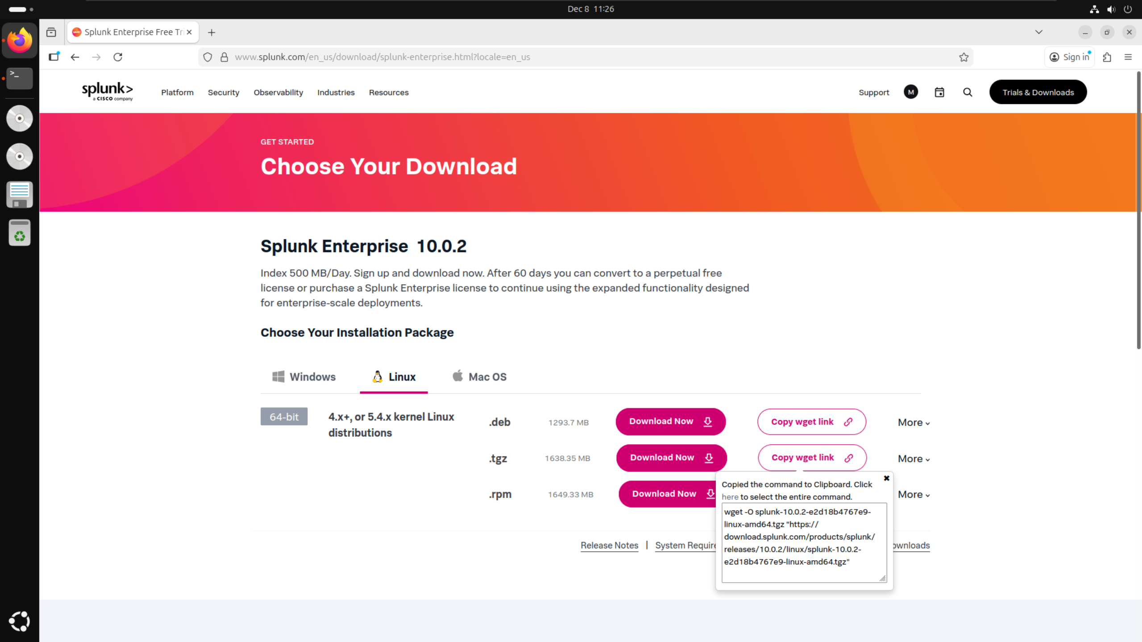

By using the wget link, I was then able to download Splunk directly from the Linux terminal by pasting the link directly into the terminal and running it. I then received a confirmation message in the terminal to state that Splunk had been successfully downloaded.

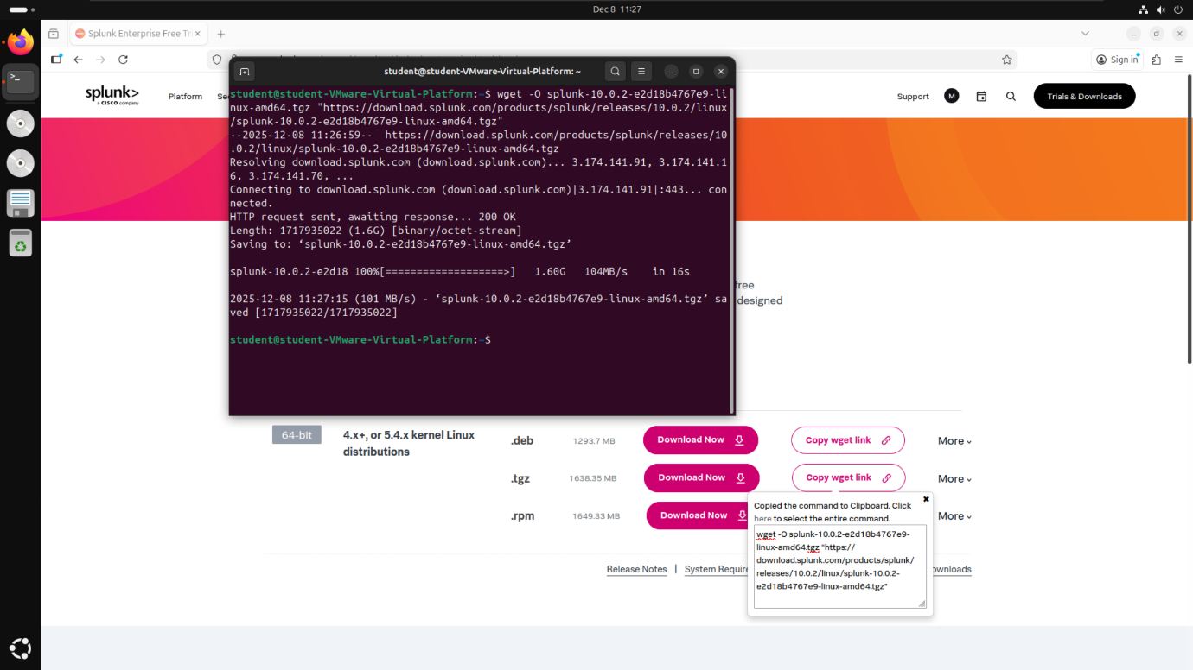

I then ran the command “sudo tar xvzf splunk-10.0.2-e2d18b4767e9-linux-amd64.tgz -C /opt” which installed Splunk and all it’s dependencies into the /opt folder. While performing the install, the terminal showed an updated list of every file being installed alongside the folders they were being installed into.

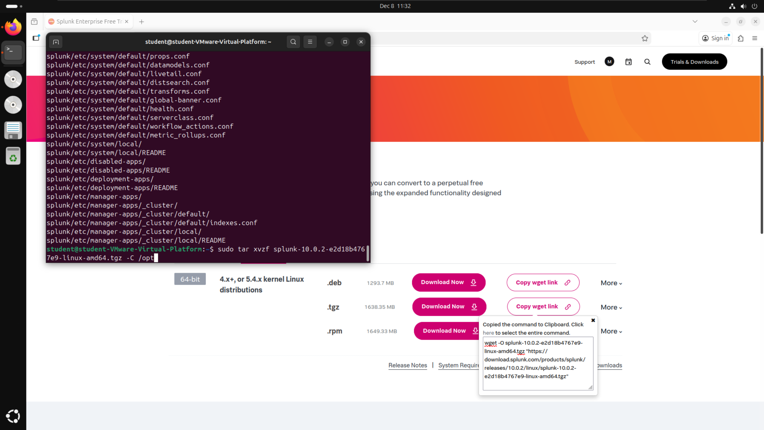

To start Splunk, I ran the command “sudo ./splunk start” from within the “/opt/splunk/bin” folder. Since this was my first time running Splunk on this installation, I had to also include the command “--accept-license” after which accepted the user license agreement for Splunk. Additionally, I had to set a username and password for the administrator account which I could then use to sign in once on localhost:8000.

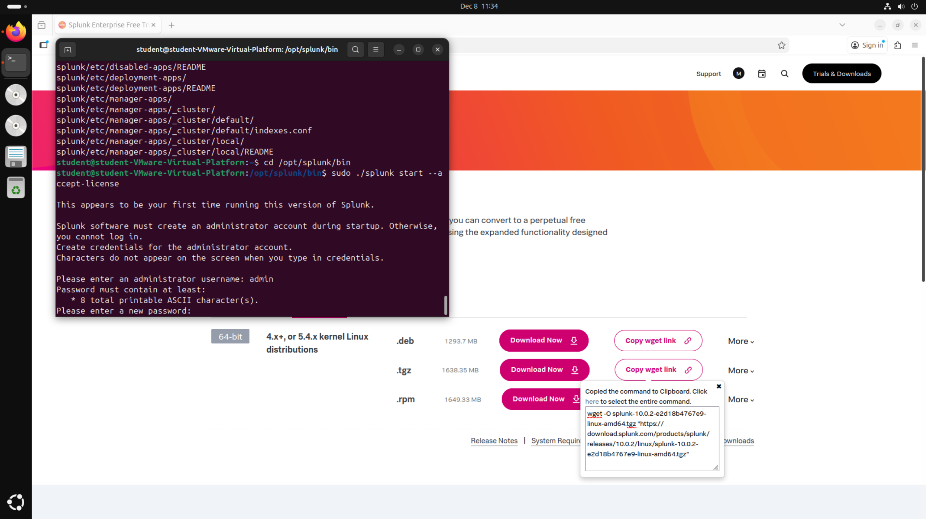

After setting up the initial login details, Splunk generated the web server on localhost:8000, providing a clickable link to the website to allow access into Splunk.

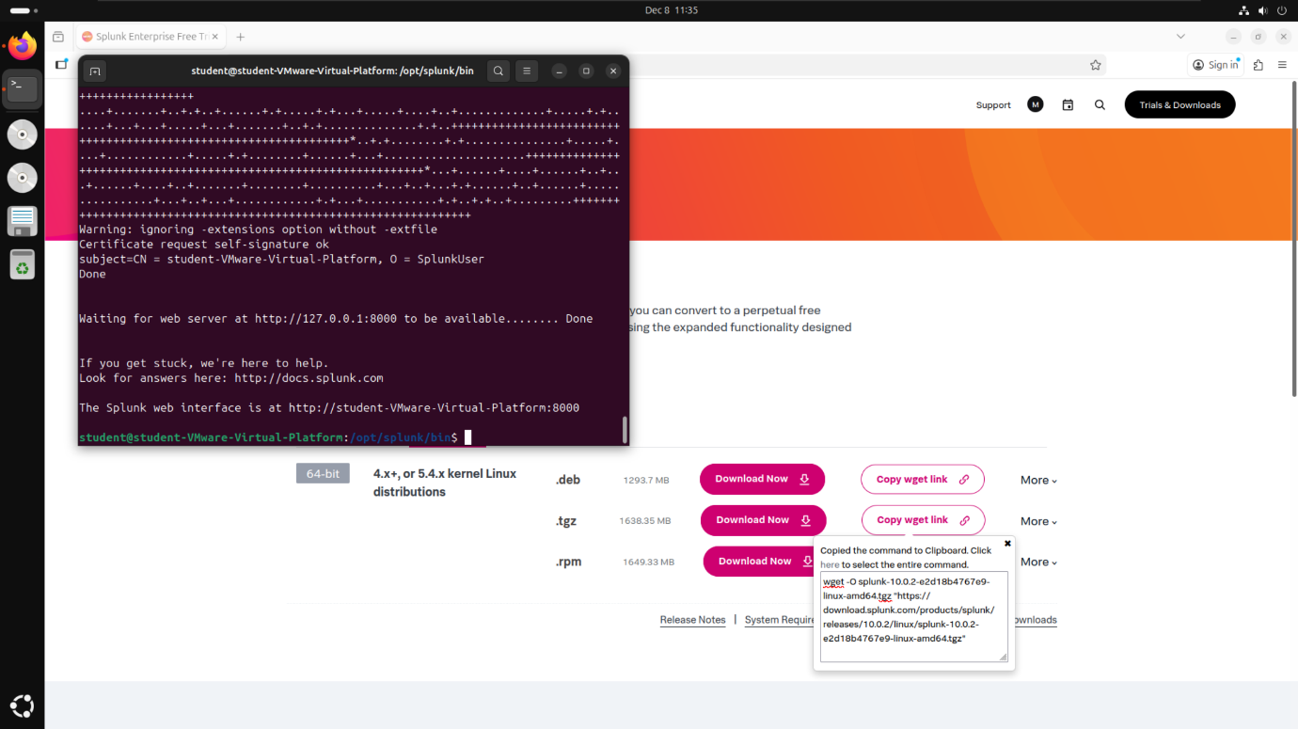

Either clicking on the link in the terminal or searching for localhost:8000 on Firefox took me to the Splunk enterprise login page. This is where I then entered the username and password I created in the previous step after starting Splunk for the first time.

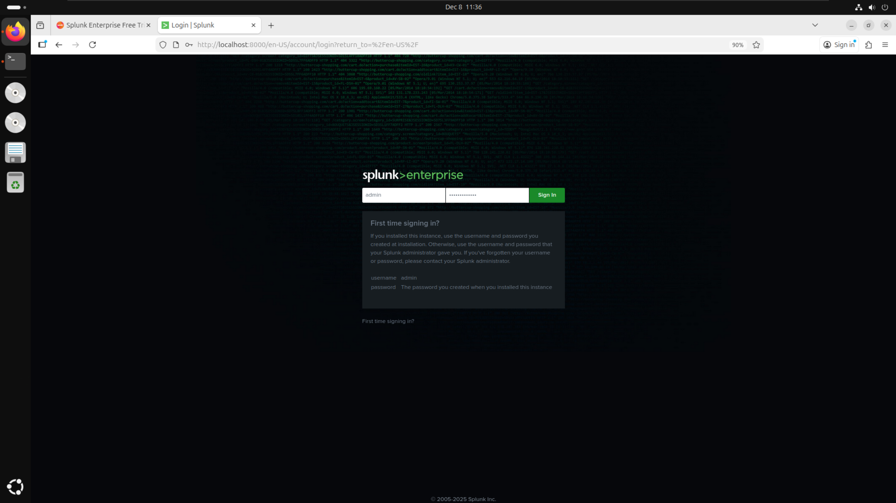

Once logged in, I was able to see the dashboard which houses all of the features which I used to answer the guided questions, most notably the “Search & Reporting” tab, which will be explained below.

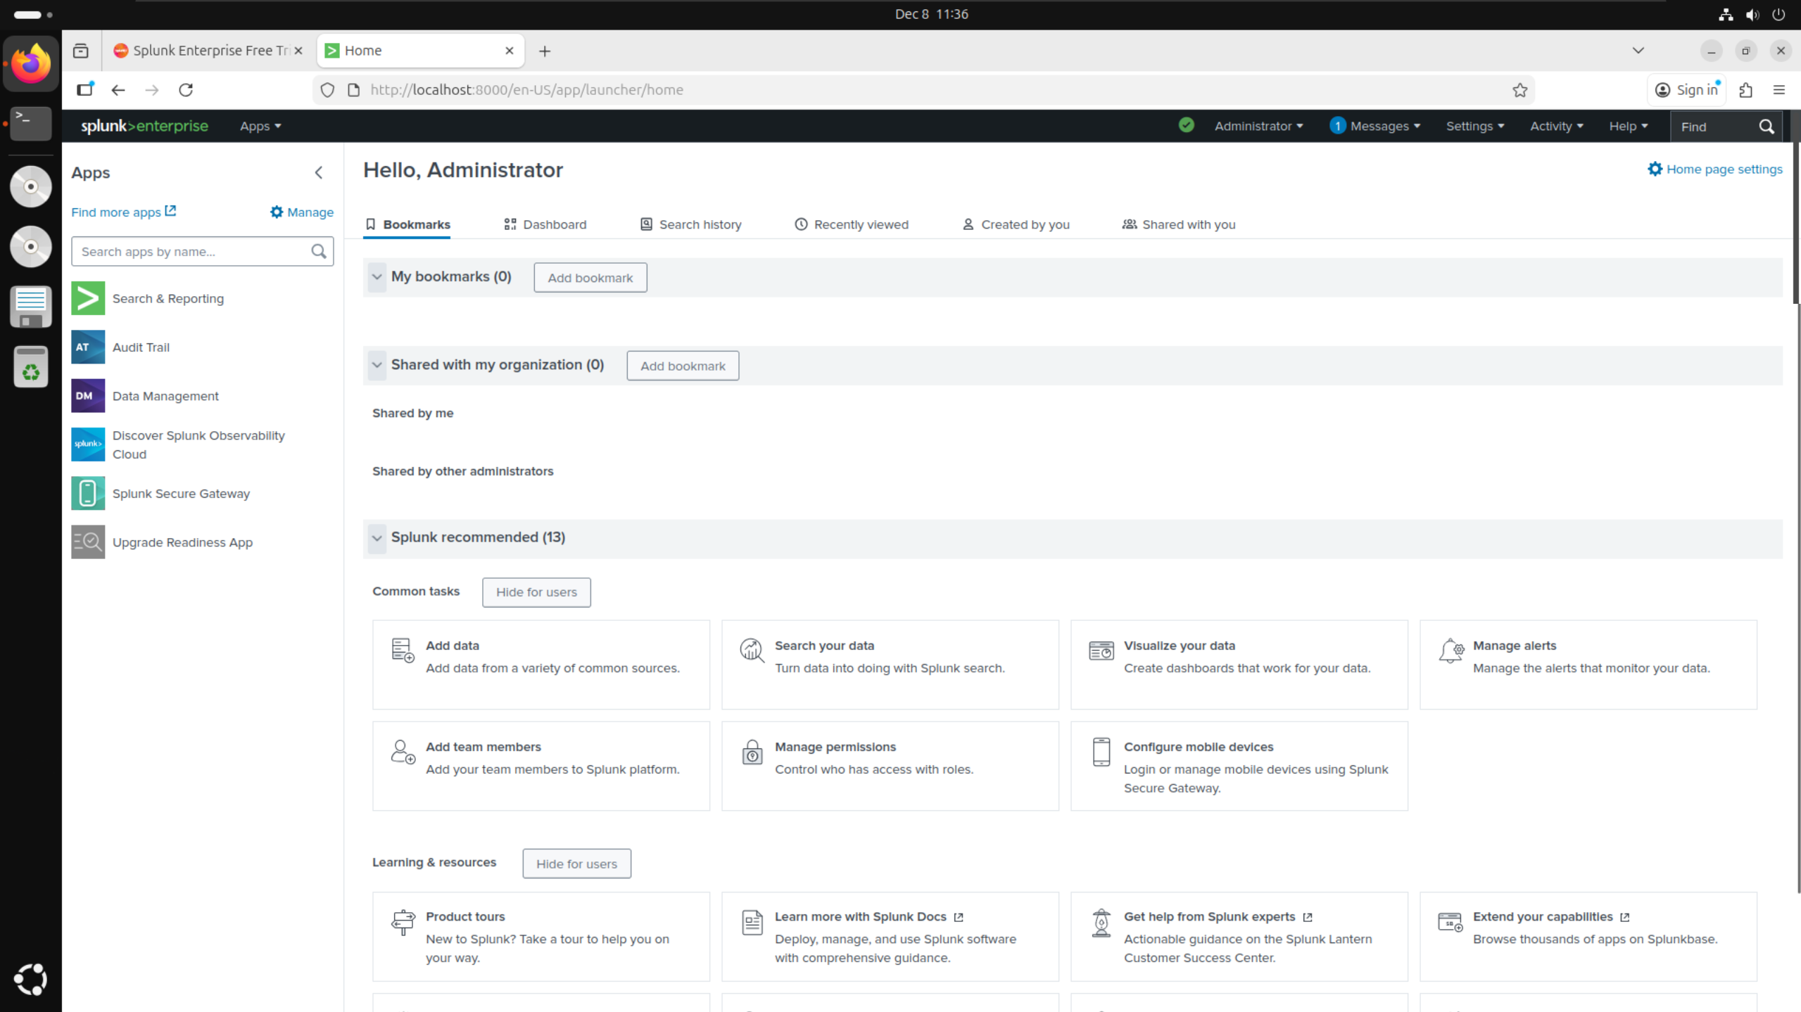

## BOTSv3 Dataset Preparation:

To download the BOTSv3 dataset, I visited the link https://github.com/splunk/botsv3 and clicked on the link under dataset in the table to download the file to my virtual machine.

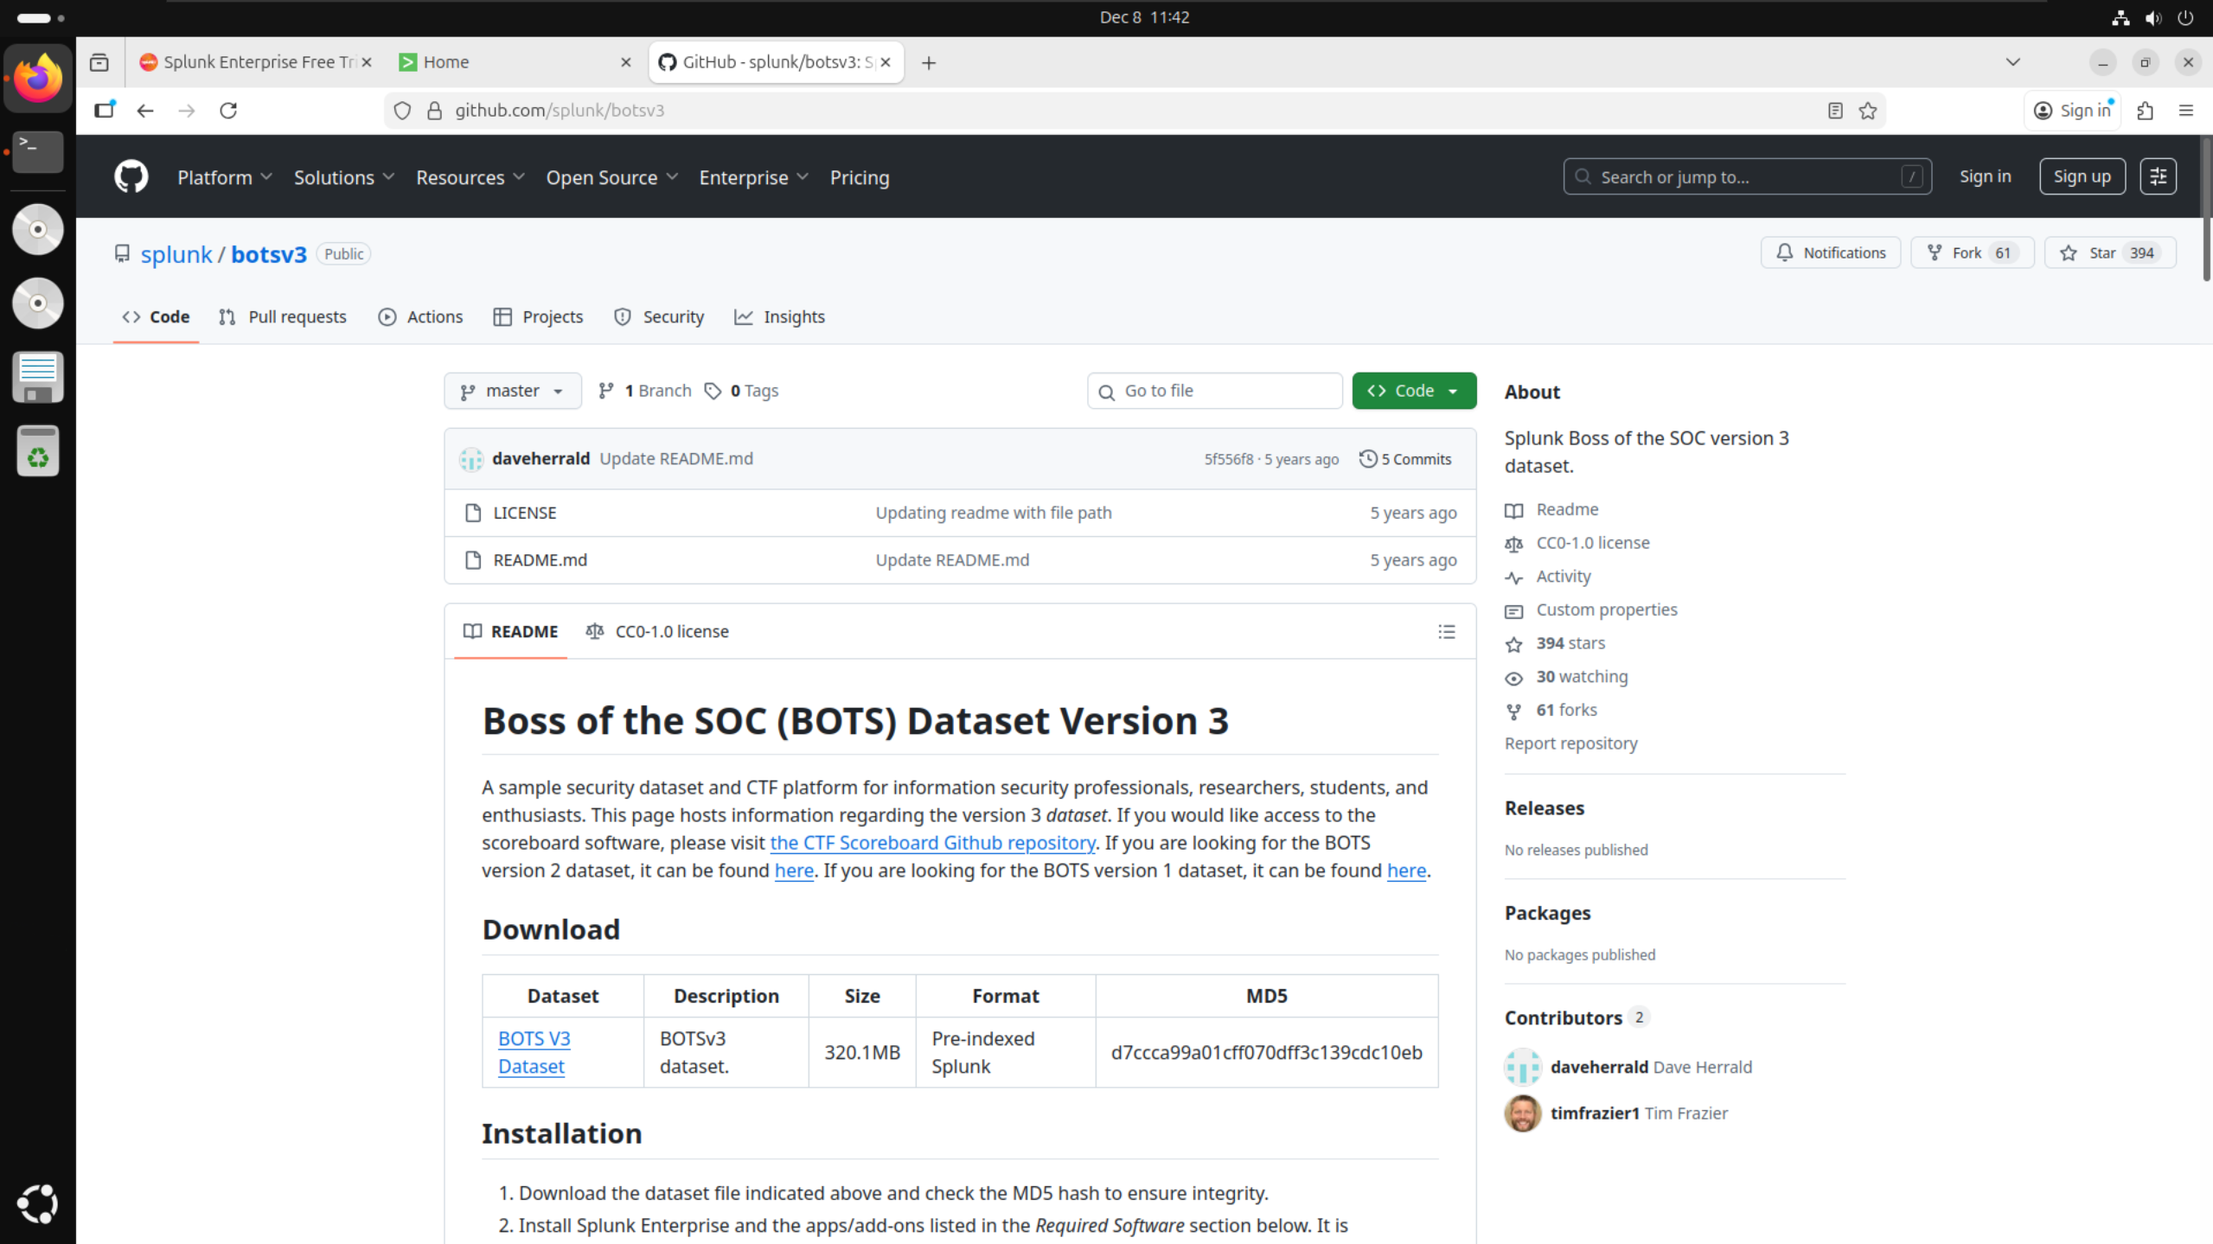

Clicking on the link downloaded the file botsv3_data_set.tgz onto my virtual machine as shown in the downloads tab on Firefox.

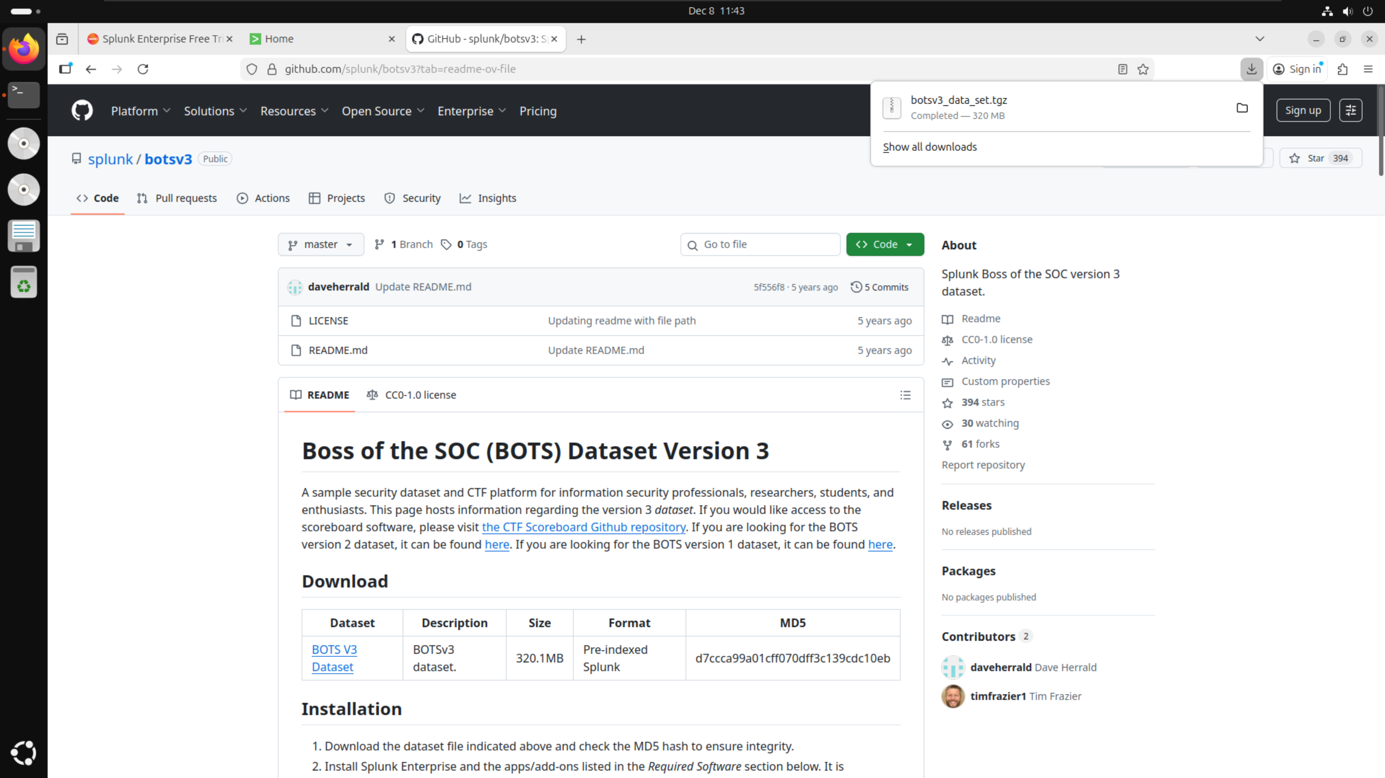

I then opened up my file explorer and navigated to the downloads folder where I found the file that I had just downloaded. I right clicked on this folder and extracted it to gain access to the botsv3_data_set folder.

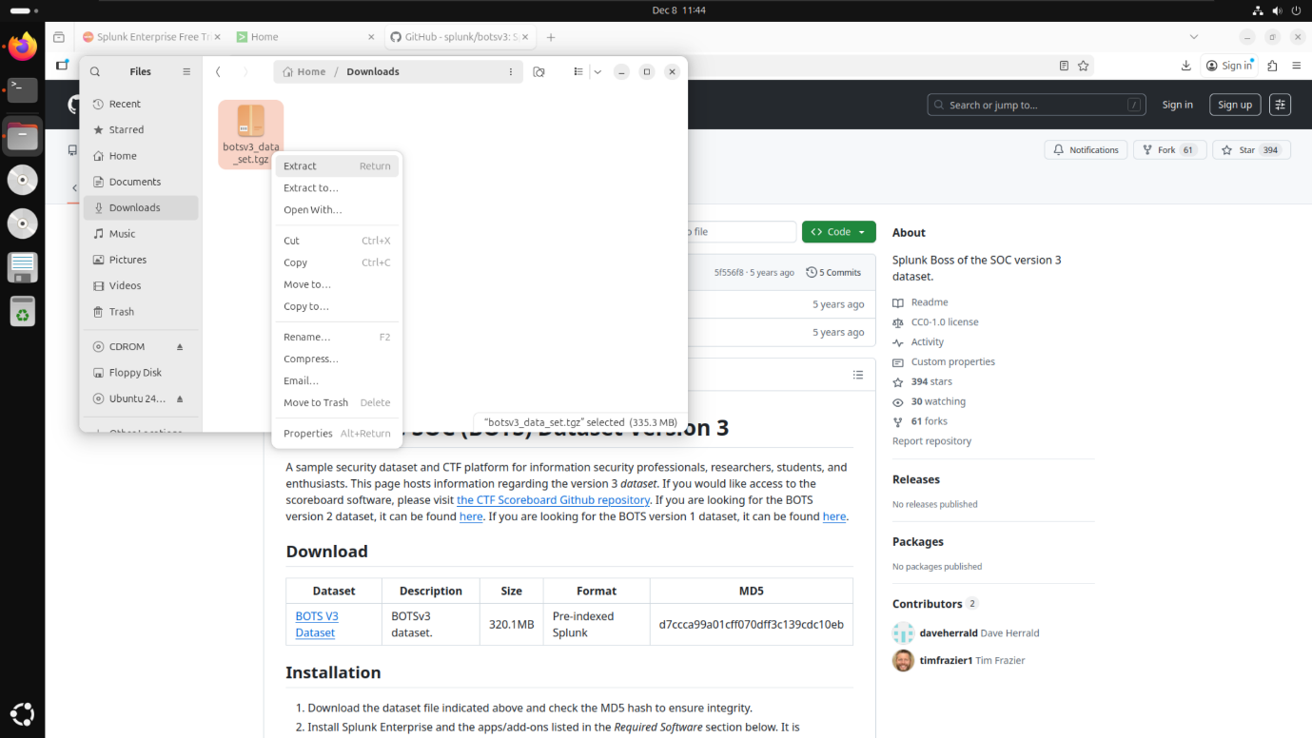  
I then confirmed that the file had extracted properly by checking for botsv3_data_set in the downloads folder of my virtual machine.

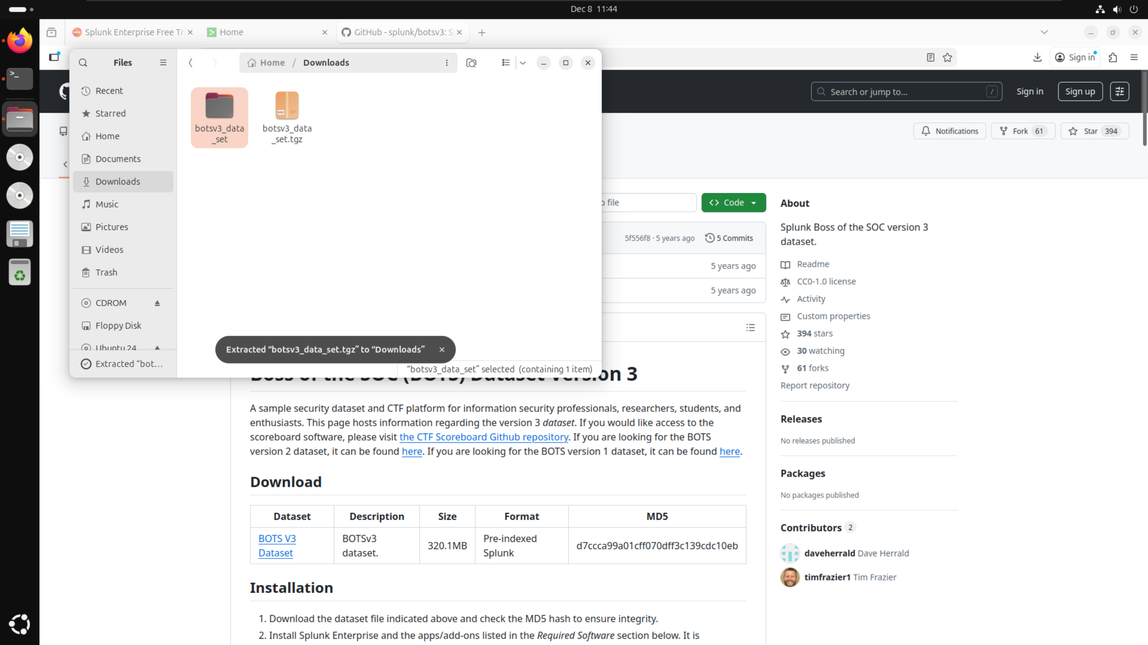

In order to copy the folder to the correct path for Splunk, I had to enter root mode in the Linux terminal. I did this by running the command “sudo su” and entering the password for my virtual machine.

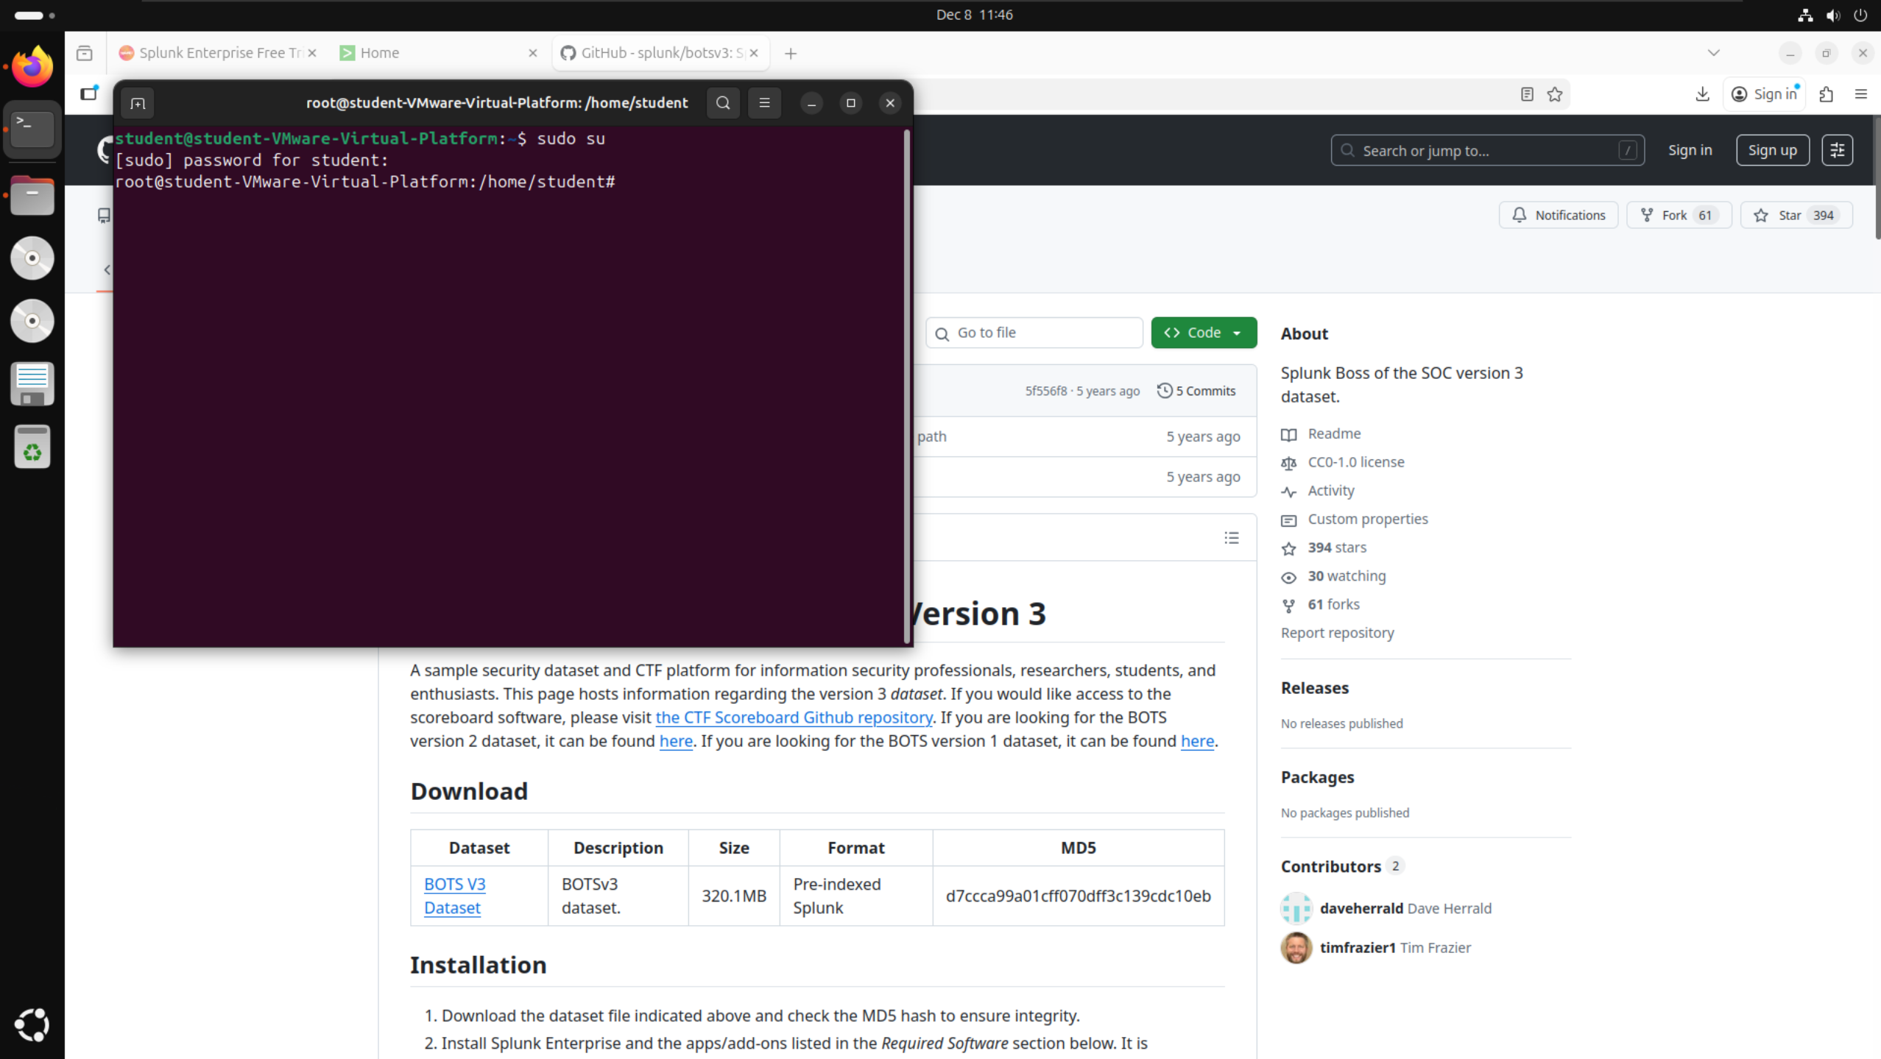

After entering root mode, I ran the command “cp -r botsv3_data_set /opt/splunk/etc/apps/” to copy the file (botsv3_data_set) into the correct path (/opt/splunk/etc/apps/) to allow it to load into Splunk correctly.

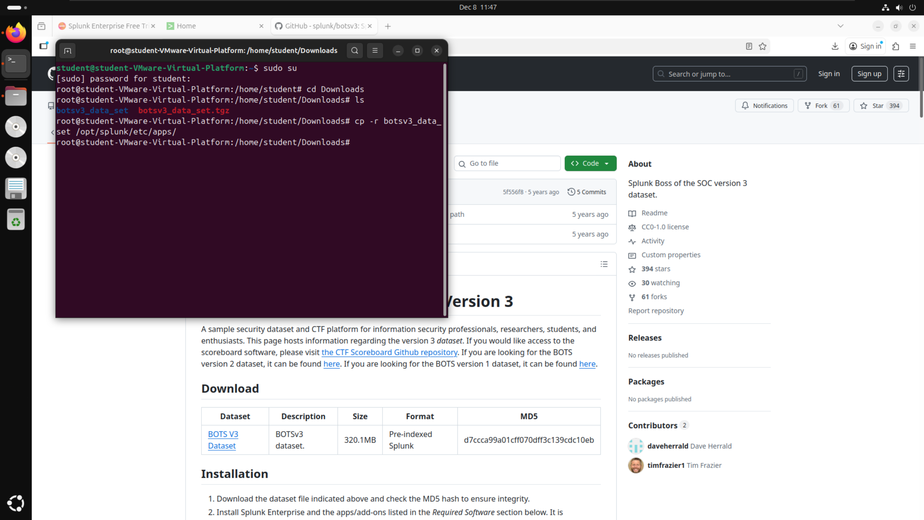

Once I had copied the file into the correct path, I navigated to that path to confirm that the file had been correctly copied, which it had.

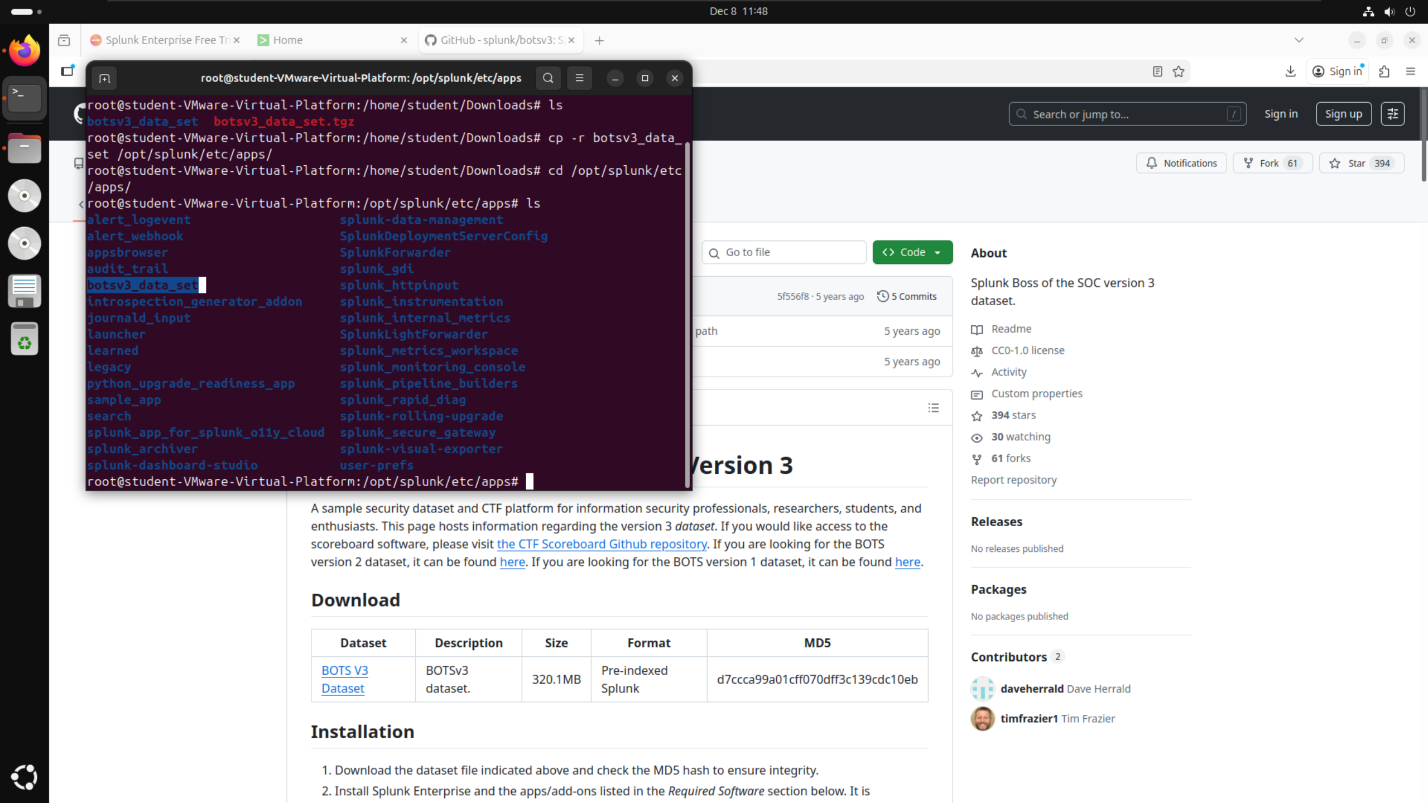

After confirming the file was in the correct location, I was able to start Splunk using the command “./splunk start”. Since I was still in root mode, I did not have to include the “sudo” command at the beginning of the line.

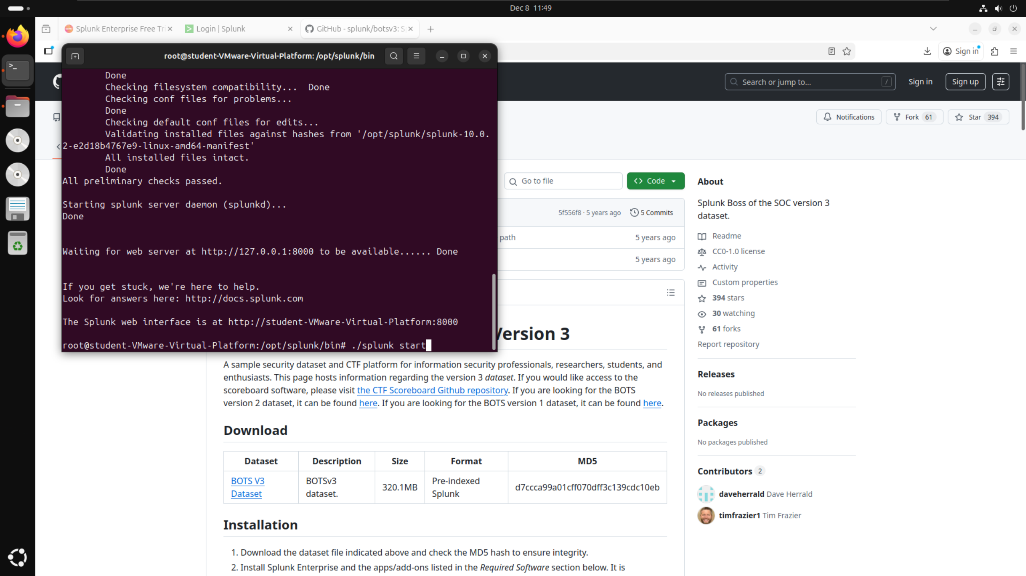

When opening Splunk by searching for localhost:8000, I was then able to navigate to the Search & Reporting page where I searched for index=”botsv3”.

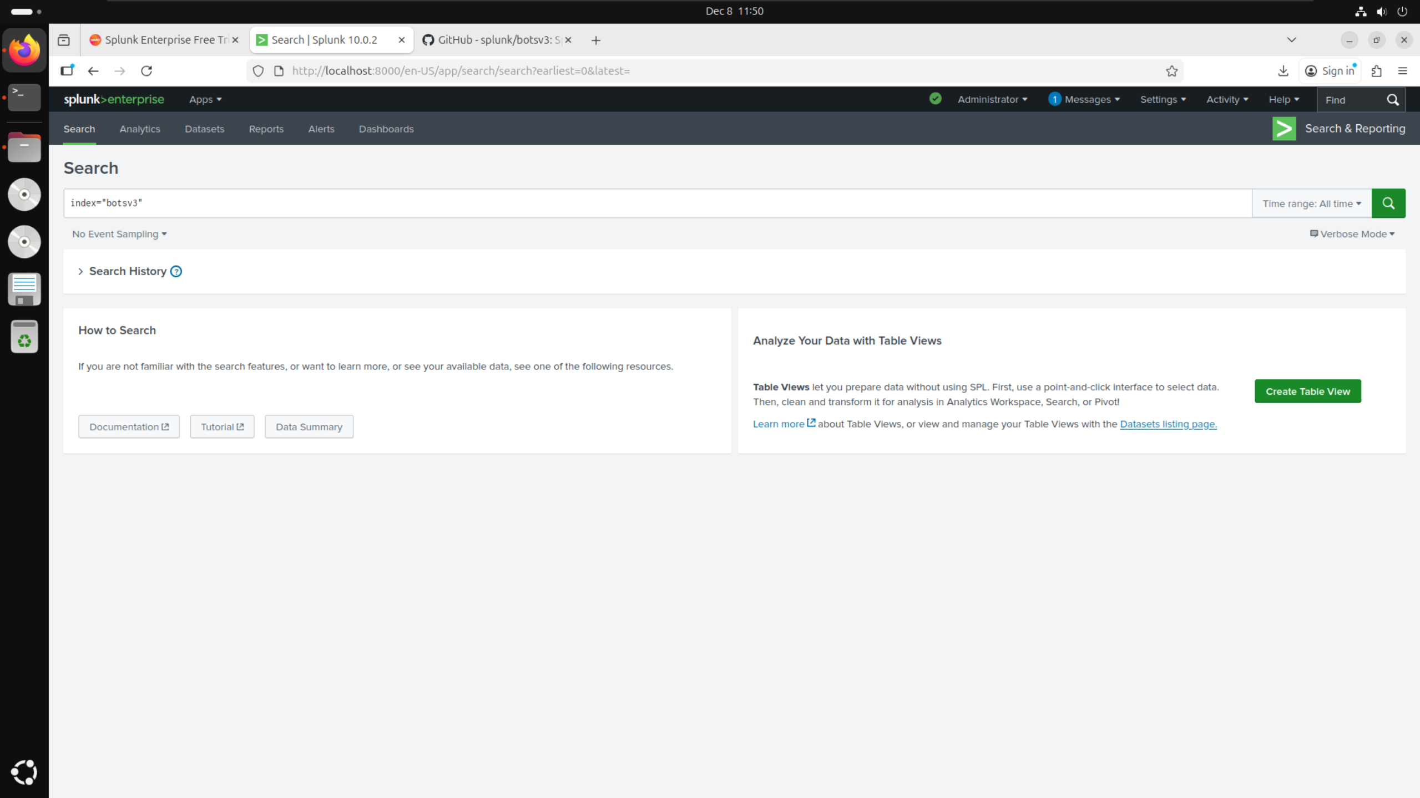

Running the search with the filter index=”botsv3” and setting the time range to filter for all time, I was then able to confirm that the dataset had correctly installed by looking at the total number of events and confirming that I had the correct number of 2,083,056 search results. After confirming this, I was then able to answer the provided questions.

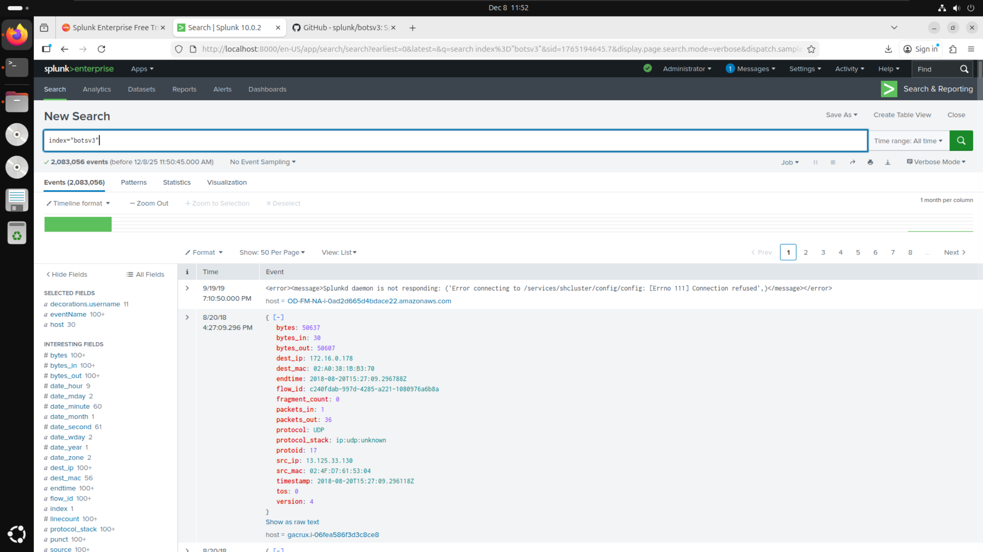

# Guided Questions:

## Question 1:

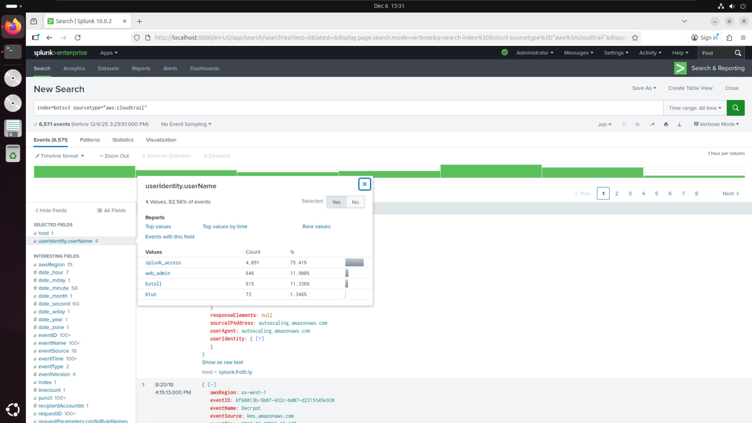

* Filtered BOTSv3 by sourcetype=”aws:cloudtrail” as given in the hints on the DLE quiz
* Searched within the filters for “username” and found userIdentity.userName filter
* Selected filter and checked values to find 4 names
* In alphabetical order: bstoll, btun, splunk_access, web_admin

## Question 2:

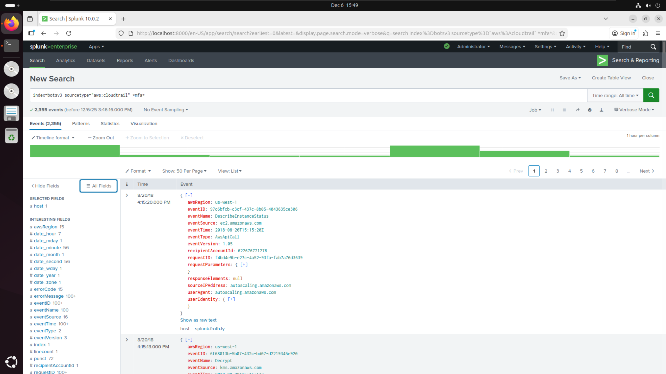

* Filtered BOTSv3 by sourcetype=”aws:cloudtrail” as given in the hints on the DLE quiz
* Added additional filter for *mfa* since looking for details relating to multi-factor authentication (using asterisks as given in the hints on the DLE quiz)

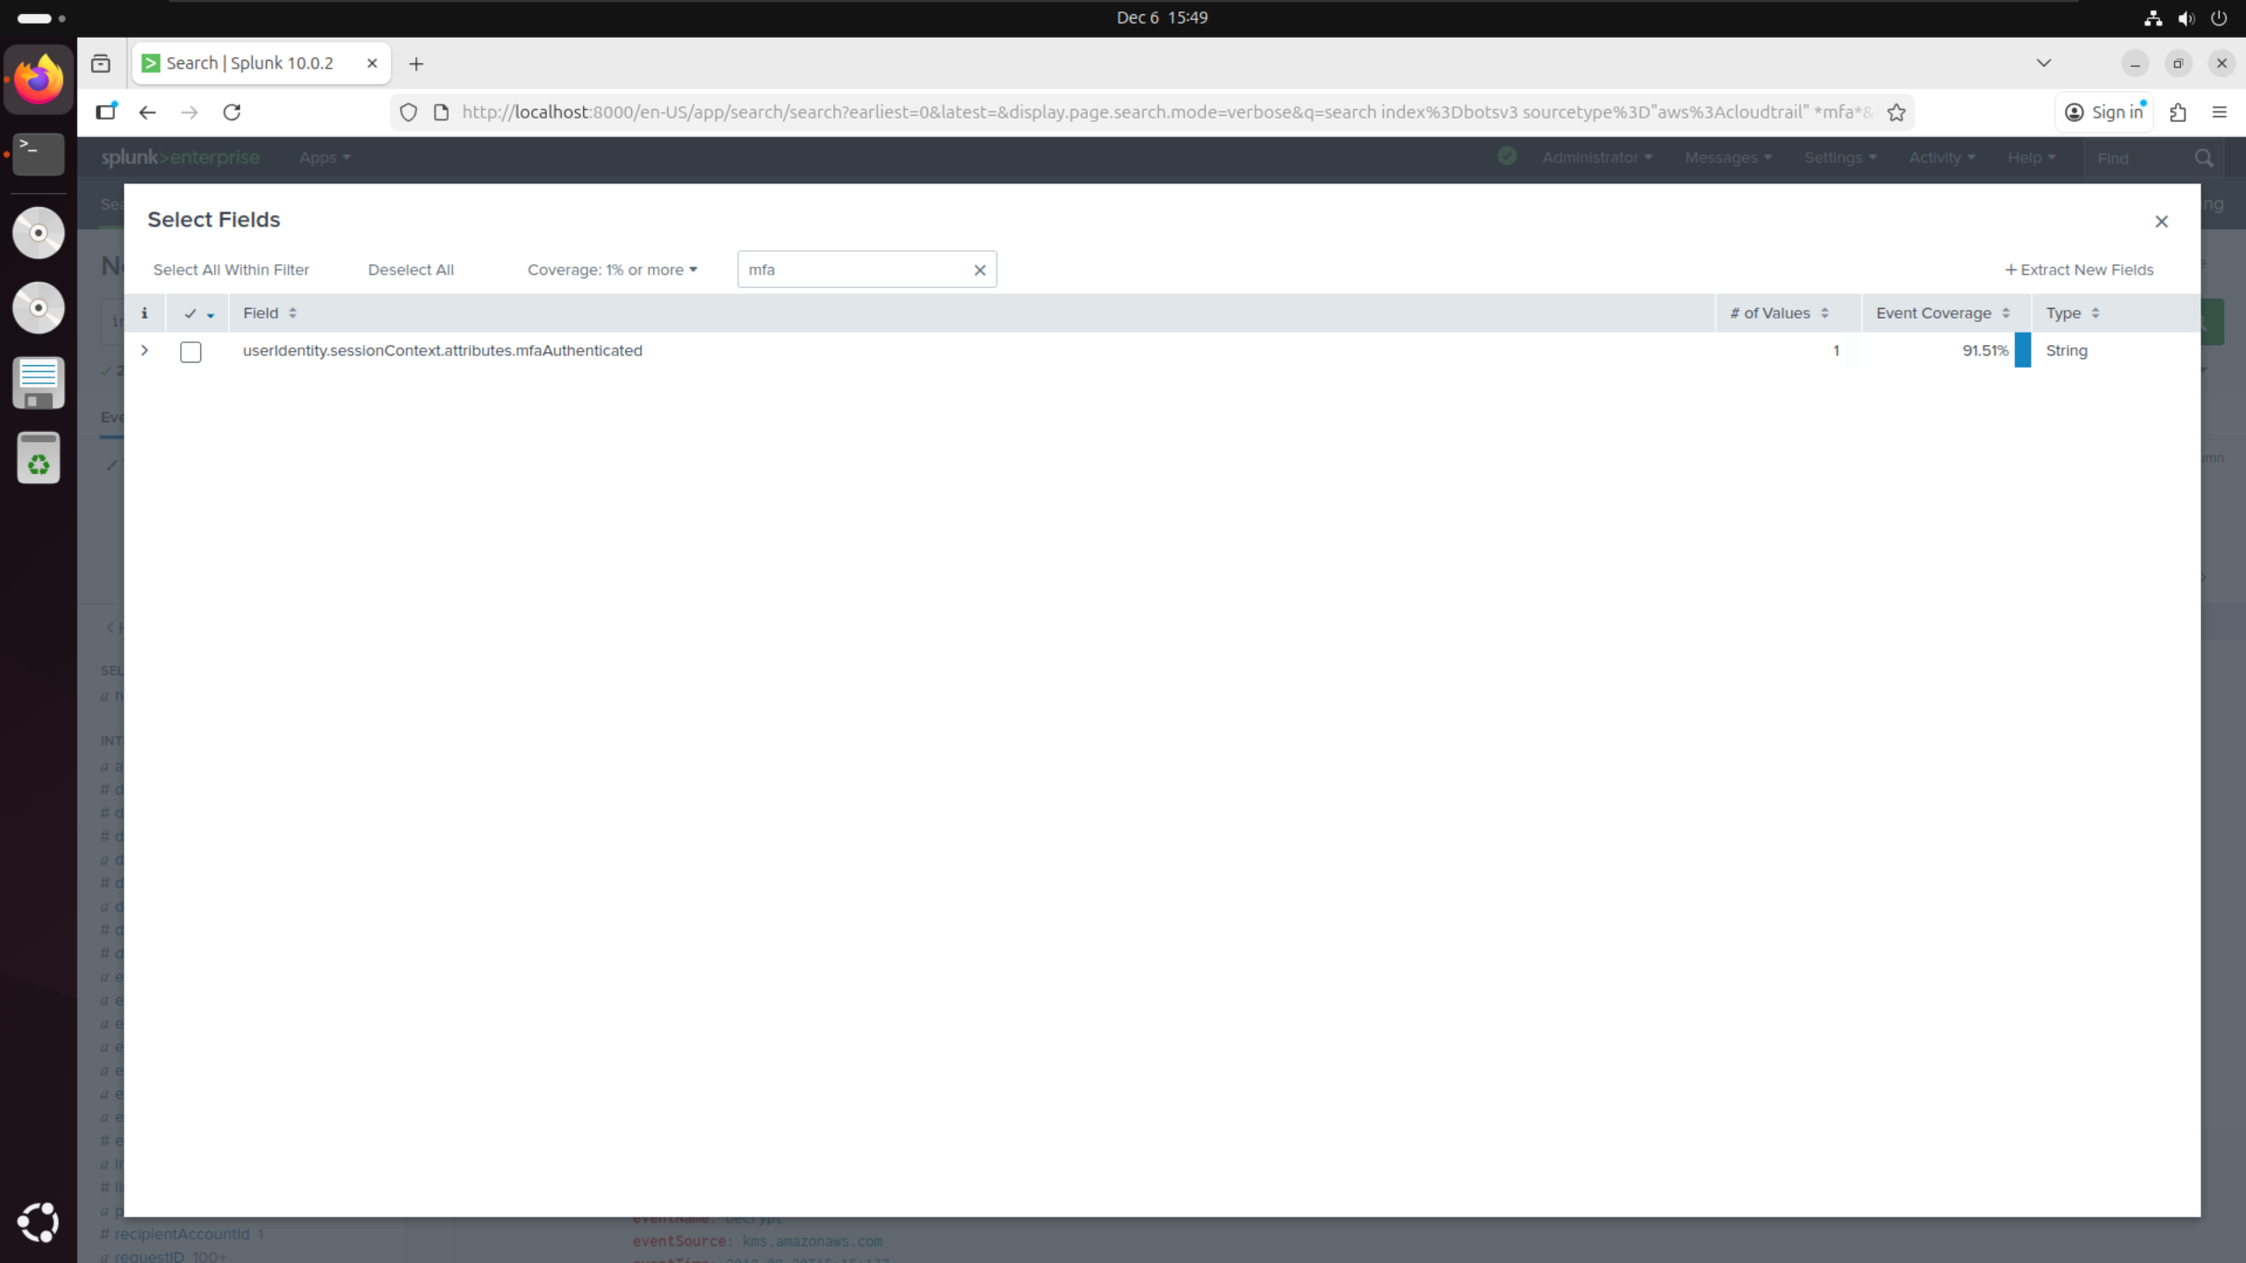

* Searched additional filters for anything related to “mfa” to find userIdentity.sessionContext.attributes.mfaAuthenticated

## Question 3:

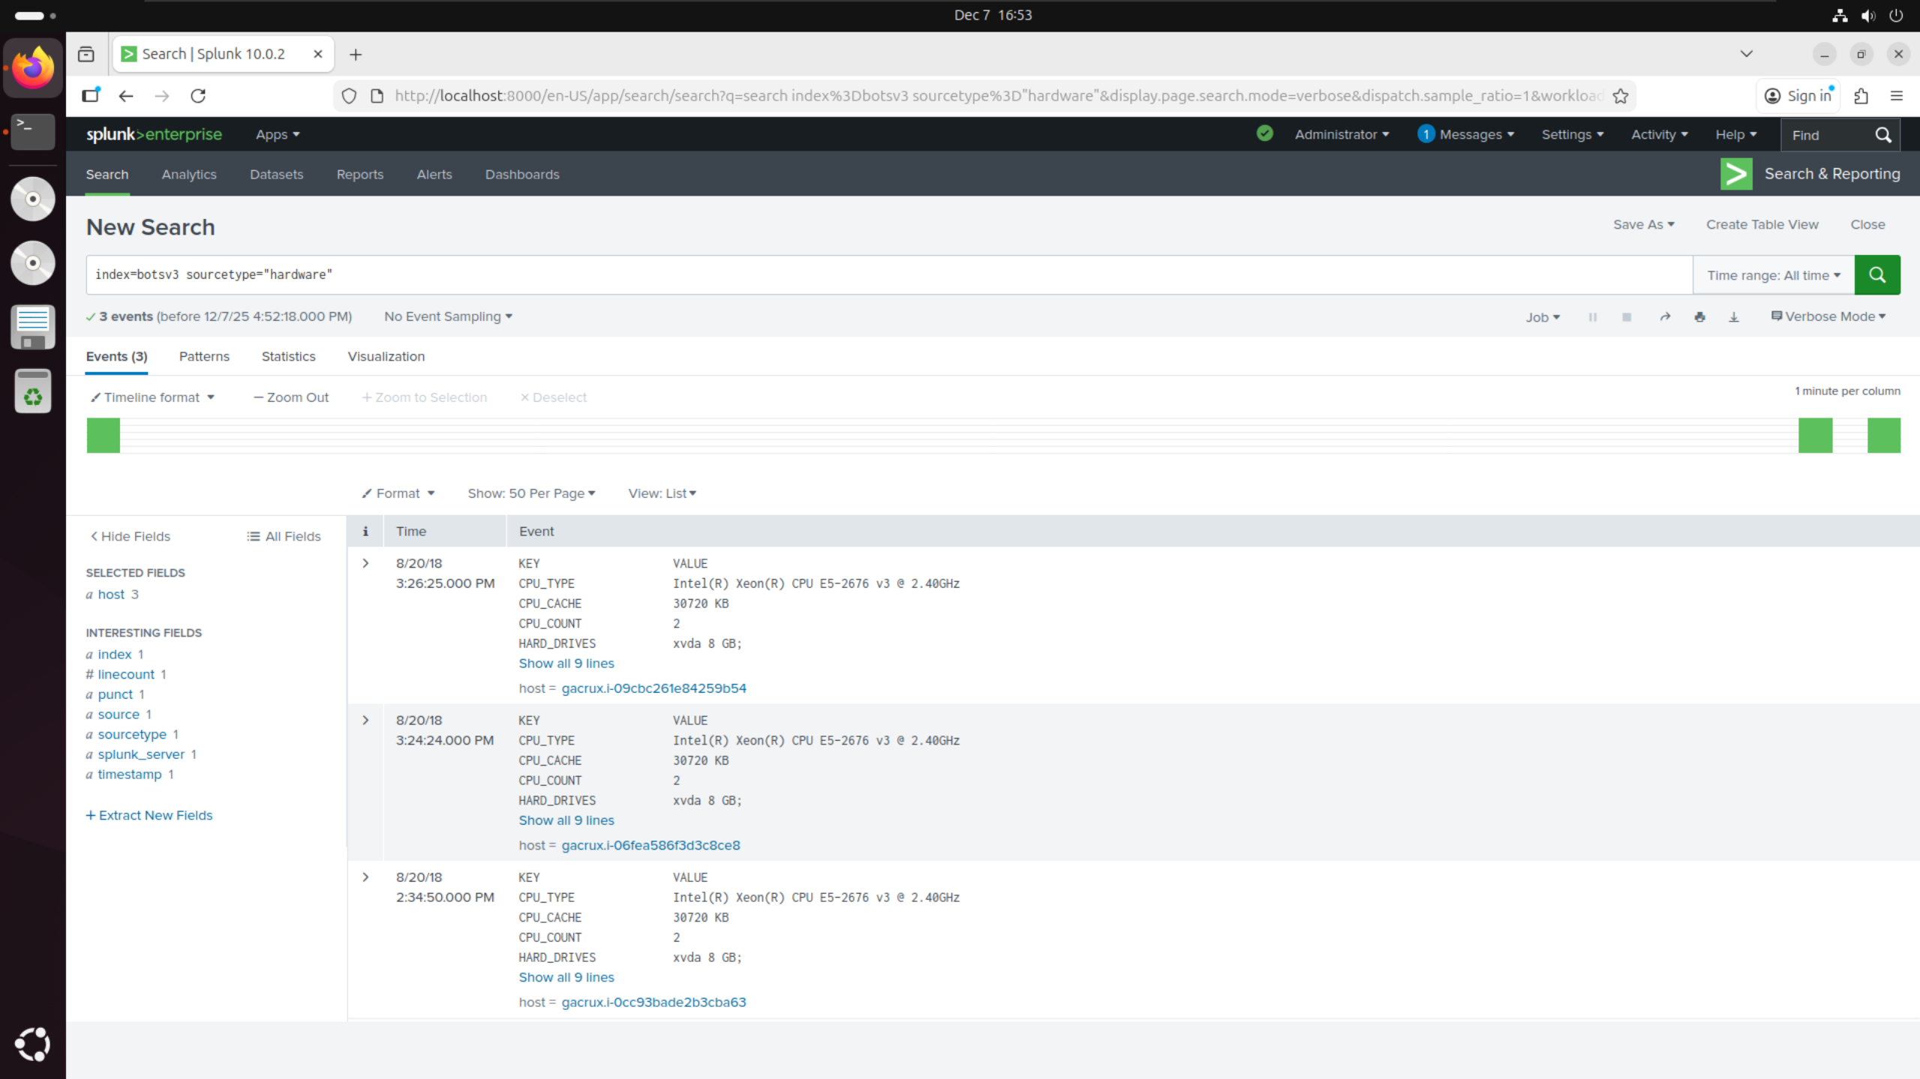

* Filtered BOTSv3 by sourcetype=”hardware” as given in the hints on the DLE quiz
* Checked value of CPU_TYPE and found the model number of E5-2676 in the correct form of **-**** given in the hints on the DLE quiz

## Question 4:

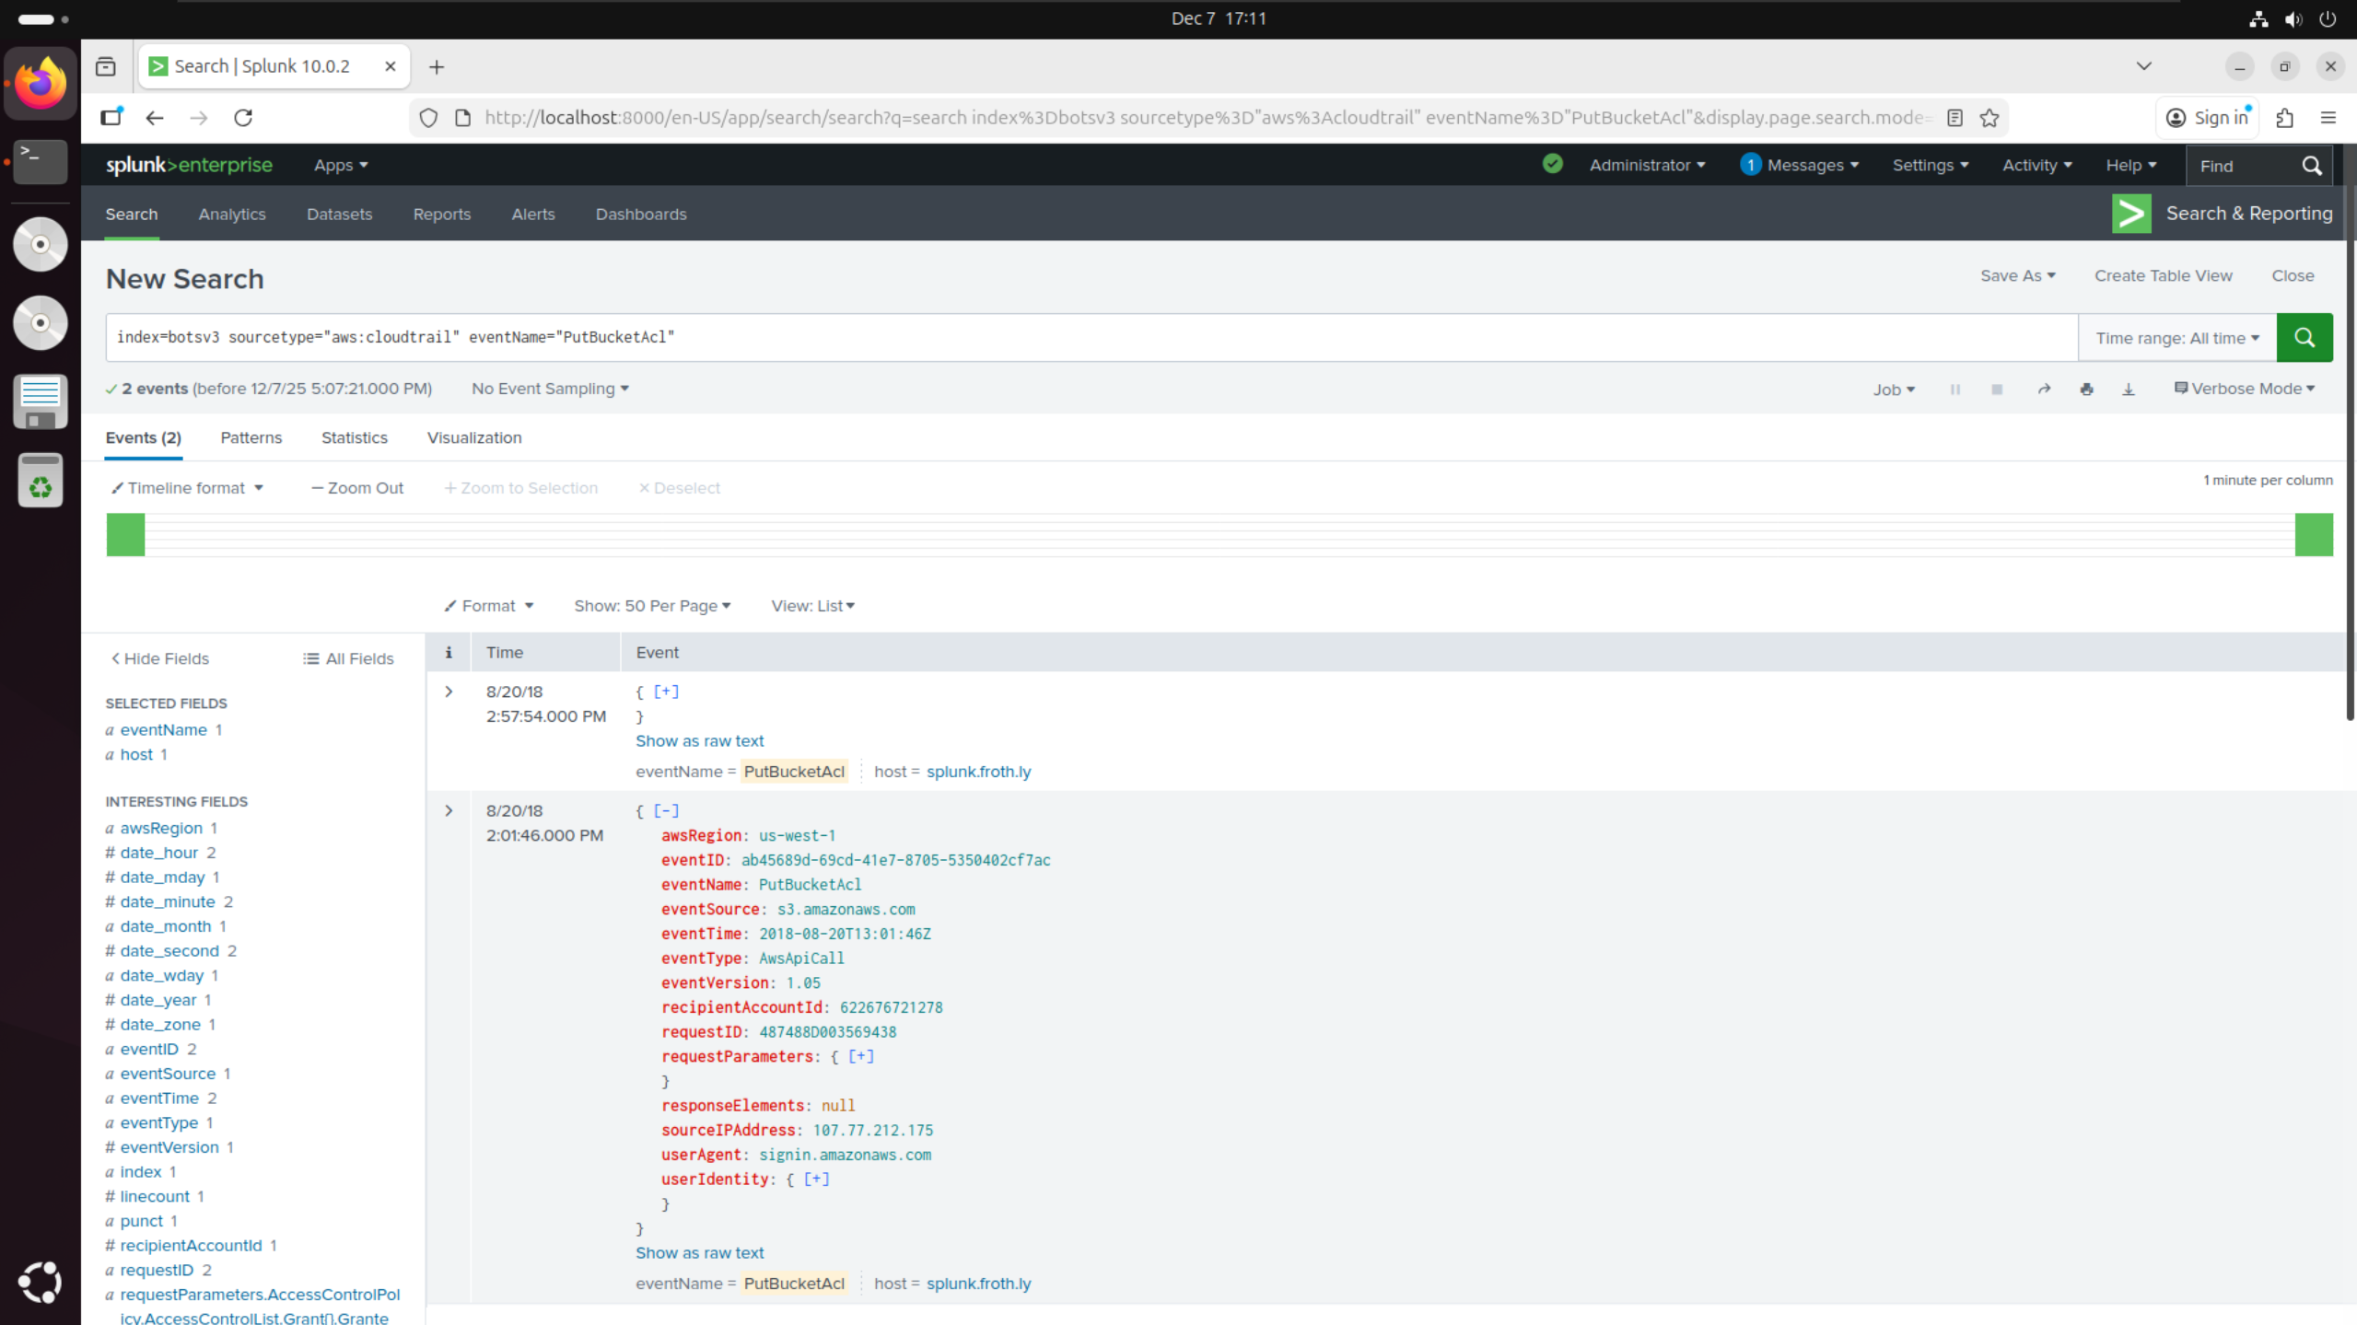

* Filtered BOTSv3 by sourcetype=”aws:cloudtrail” and specific eventName=”PutBucketAcl” as given in the hints on the DLE quiz
* Noticed 2 events with this event name but different event IDs
* Assumed these events would be user accidentally making the S3 bucket public (older event) then making it private again (newer event) giving the correct eventID as ab45689d-69cd-41e7-8705-5350402cf7ac

## Question 5:

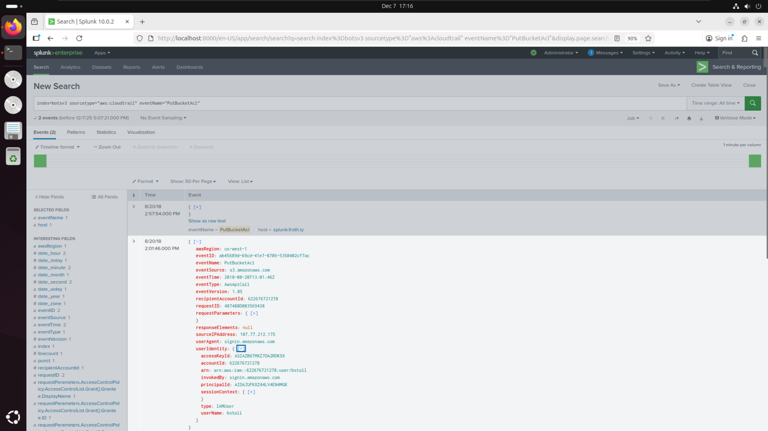

* Applied same filters as question 4
* Opened userIdentity field within the relevant event and found userName: bstoll

## Question 6:

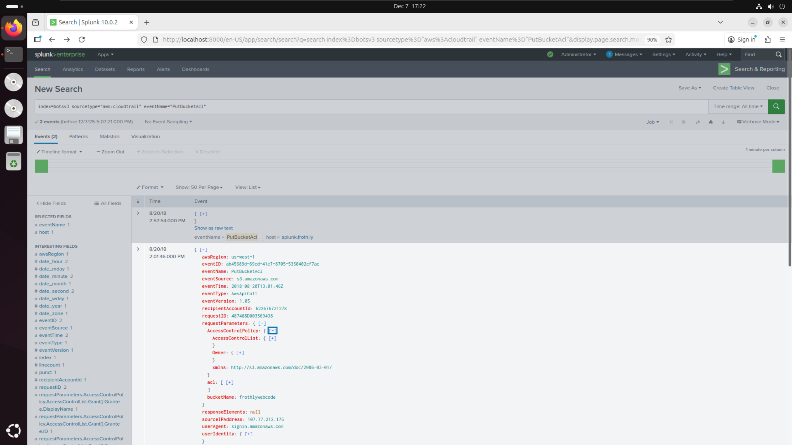

* Applied same filters as question 4
* Opened requestParameters field within the relevant event and found bucketName: frothlywebcode

## Question 7:

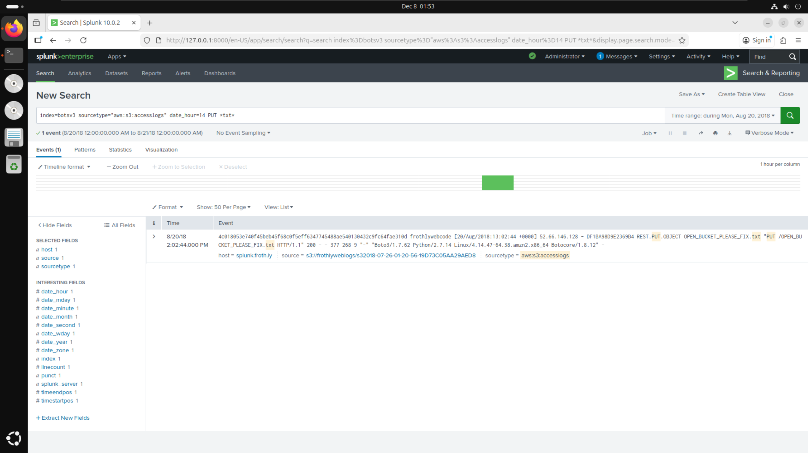

* Filtered BOTSv3 by sourcetype=”aws:s3:accesslogs” as given in the hints on the DLE quiz
* Filtered specifically for events at date_hour=14 since questions 4-6 show both events occur between 2pm
* Filtered for PUT requests as suggested by the question since this event involved uploading a file to the bucket
* Filtered for *txt* since the question asked for the name of the text file uploaded therefore hinting it would be a .txt extension

## Question 8:

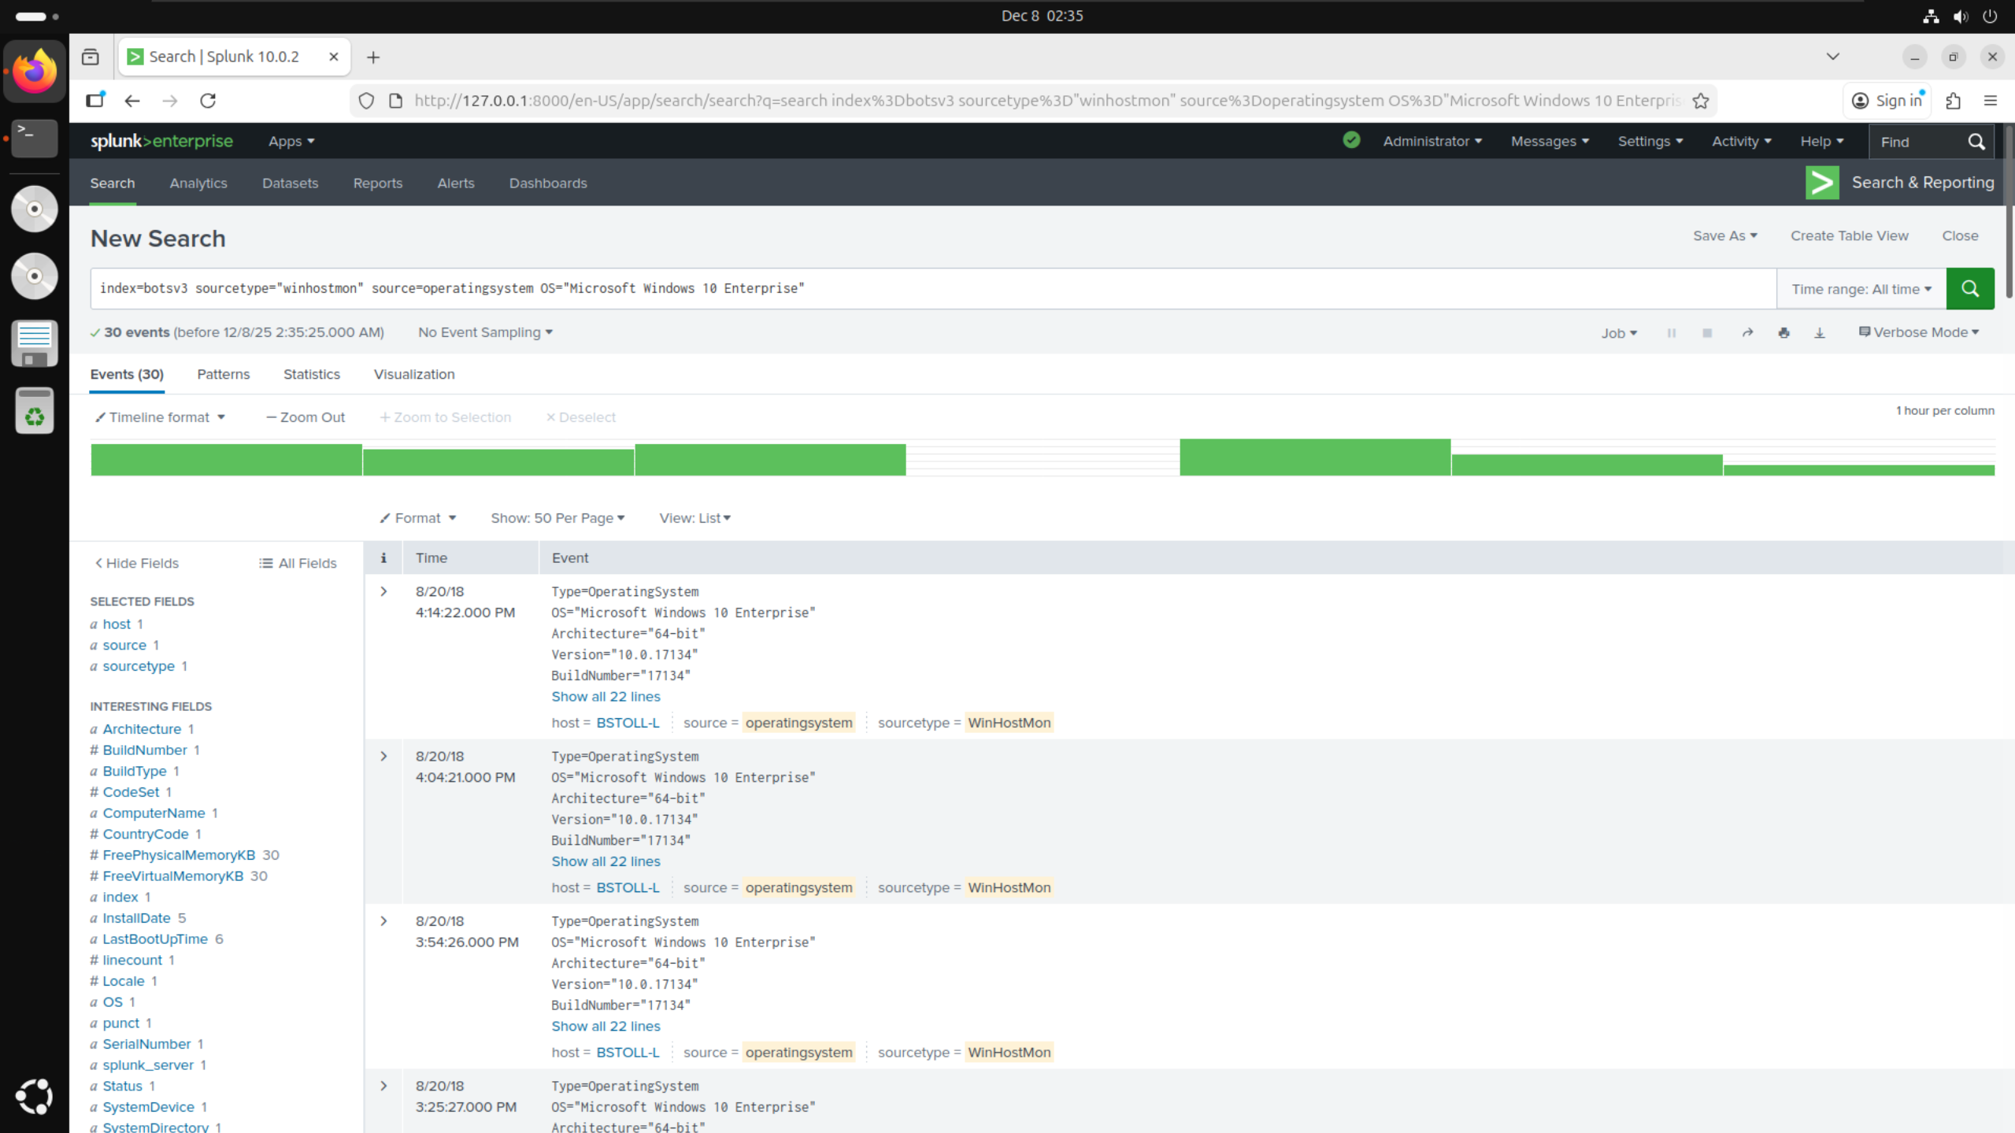

* Filtered BOTSv3 by sourcetype=”winhostmon” as given in the hints on the DLE quiz
* Searched though the filters list to find source filter and selected source=”operatingsystem” from the list
* Searched through the filters list again to find OS filter and selected OS=”Microsoft Windows 10 Enterprise” from the list as it had the least uses -> Was used 30 times by only one user

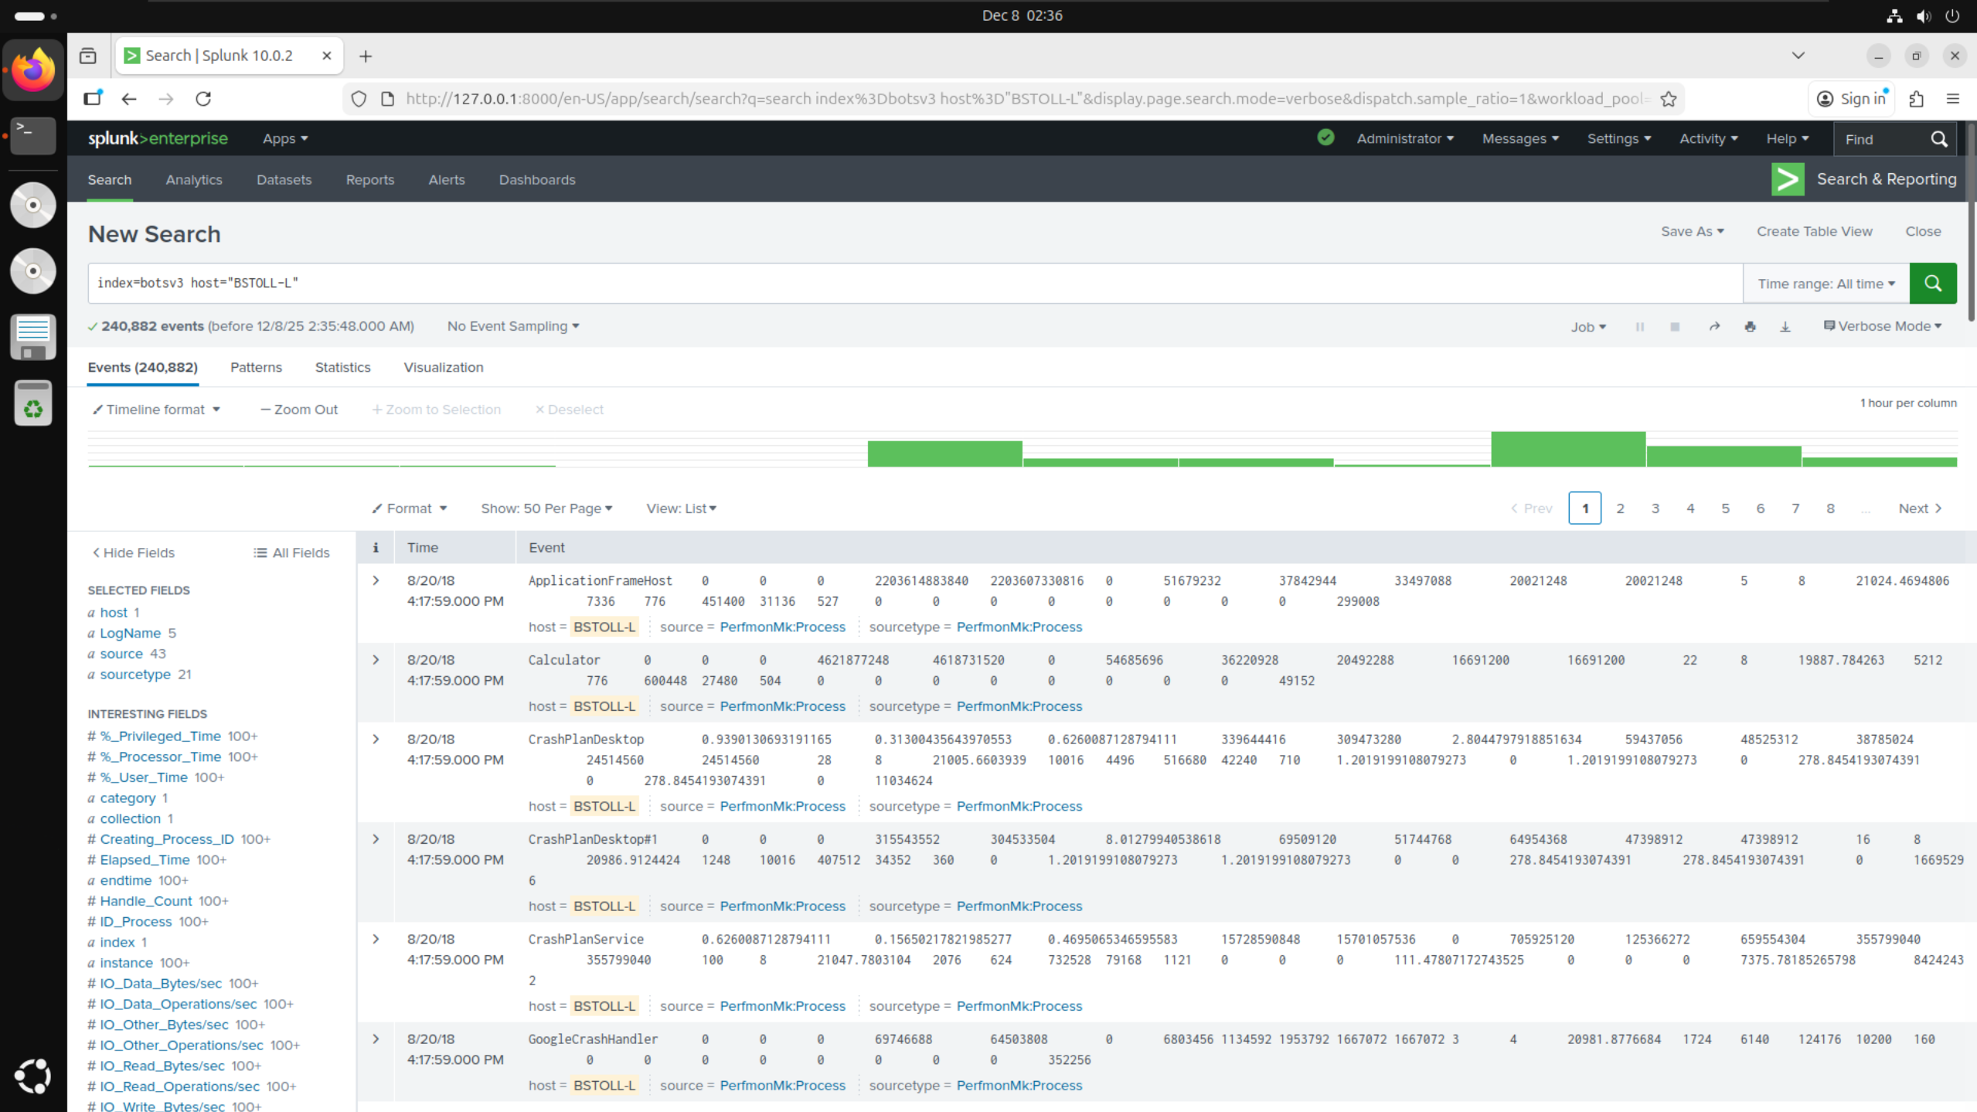

* Added host=”BSTOLL-L” from the initial search into a new search to look for any filters with the FQDN

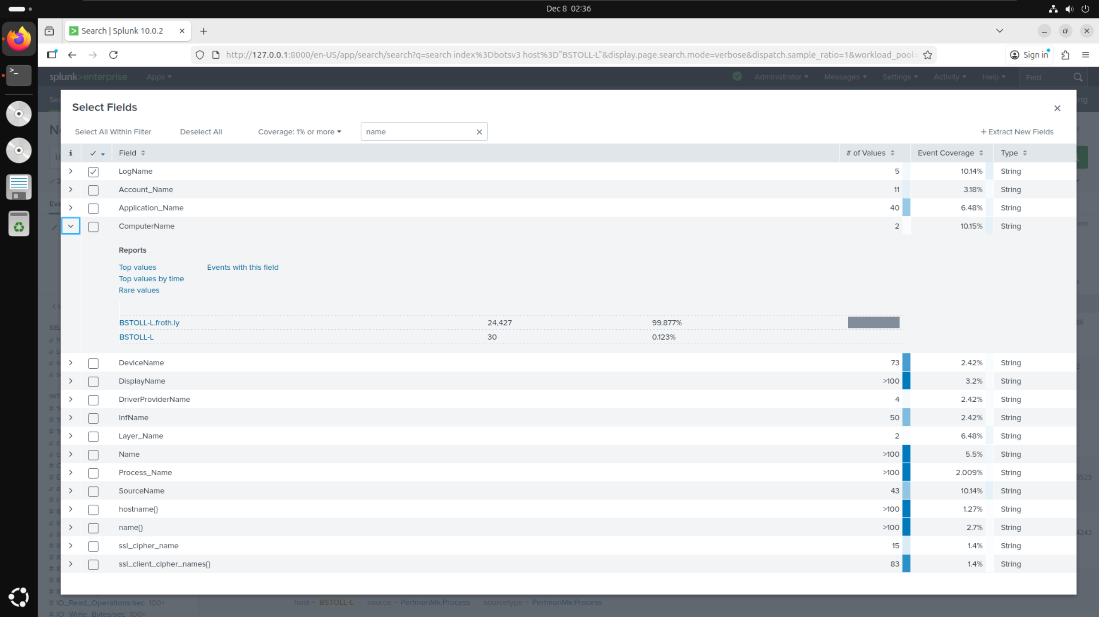

* Initially searched filters list for FQDN but could not find anything so instead searched for “name”
* Found filter called ComputerName which had the value of BSTOLL-L.froth.ly

# Conclusions:

# References: